**CSS can be applied to html attributes directly, not only on classes:**



**<em>: emphasize element, will make the text italic**

**<i>: idem but with different meaning, same result**

**<strong>: bold element**

**<b> : idem**

**<sup> and <sub>: superscript (4th) and subscript (*H2) elements***

**Certain elements occupy the entire block:**

**p for example:**

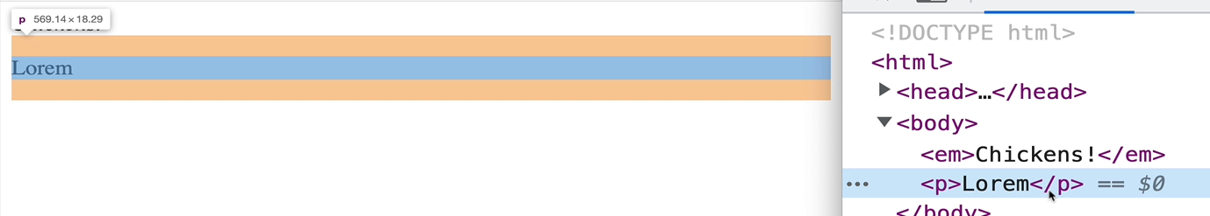

**Other elements (called Inline Elements) occupy just the space that they require for their content:**

* **span, sup, sub etc …**

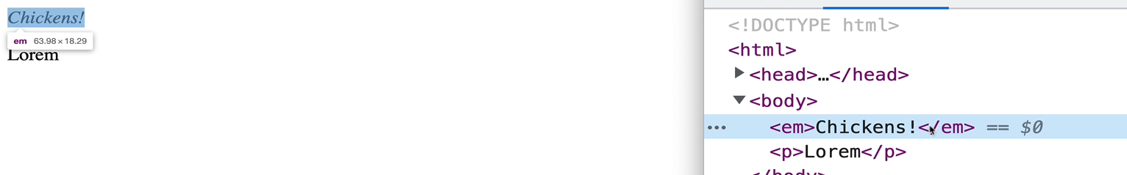

**That’s why in this next example:**

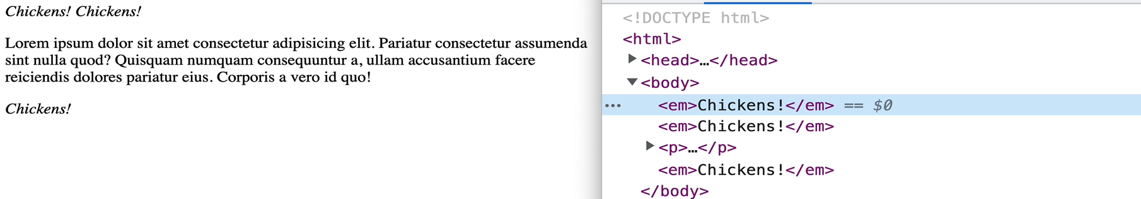

* **The last “Chickens” element is forced onto its own line. Because it’s placed after a p, and the p occupies a whole block.**
* **We can see the first and second “Chickens” elements are displayed one after the other.**

**Spans: generic INLINE container**

* **If we have multiple words in a paragraph, we can wrap a certain word in a span and apply css styles to it.**

**Divs: generic BLOCK containers**

**Make sure Semantic Markup is something that is kept in mind. Elements which don’t have a styling of their own but just provide meaning to the content.**

[**https://developer.mozilla.org/en-US/docs/Glossary/Semantics#semantic_elements**](https://developer.mozilla.org/en-US/docs/Glossary/Semantics#semantic_elements)

* **<main>**
* **<header>**
* **<footer>**
* **<nav>**
* **<aside>** 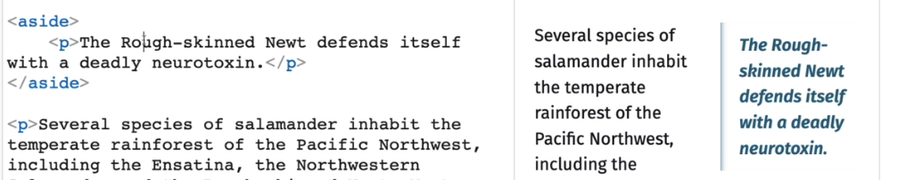
* **<time>**
* **<article>**
* **<section>**
* **Etc…**
* **color: changes color of text**
* **background-color: changes the background color**
  + **Trick for coloring elements. We can set the background color to a certain color and put an opacity over it such that the element now has a slightly more colored version of the color it has behind it. Put dark for a slightly darker version etc…**

**Opacity**

* **For RGBA, there is a 4th parameter for opacity, with values from 0 -> 1**

**example: rgba(0,255,255,0.5).**

* **Another way to do this is using the opacity property**

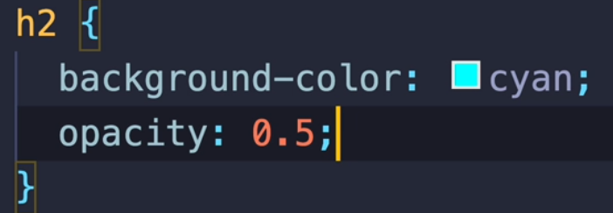

**opacity can also be expressed as a percentage, i.e opacity: 50%.**

* **The second method will make the modify the opacity of the whole h2 element while the first method would only apply opacity to the background-color of the element**

**Inheritance**

* **Certain properties are not inherited by the children**
* **If we want to force inheritance**

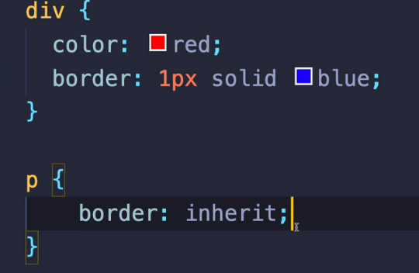

**In this example, the paragraphs which are children of the div, will inherit its border property, even though the border property is not inherited by default.**

* **Useful site for seeing which properties get inherited:**

[**https://www.w3.org/TR/CSS22/propidx.html**](https://www.w3.org/TR/CSS22/propidx.html)

**8 – Styling Text**

* **font-family: Changes the font.**
  + **We provide to it a particular font or a family of fonts**
  + **If the font has a space in its name, we have to wrap it in quotes**
  + **example : serif fonts with those edges or sans-serif fonts without those edges (called serifs)**

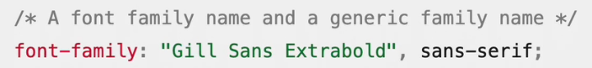

* + **Font stack : a list of fonts to be used. In case the first one isn’t available on a certain machine, the next one will be tried and so on**

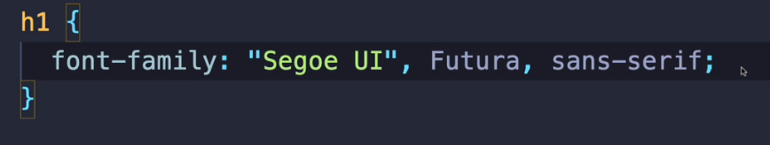

* + - **Try segoe first, futura second, or any sans-serif font ( because this is the name of a font family) if you cannot use the previous ones**
  + **fonts are inherited**

* + **See font availability on different platforms here:**

[**https://www.cssfontstack.com/**](https://www.cssfontstack.com/)

* **font-size: size of text, receives units.**
* **font-weight: boldness/weight of text**
  + **Different fonts can have different options for weight. Not all of them !**

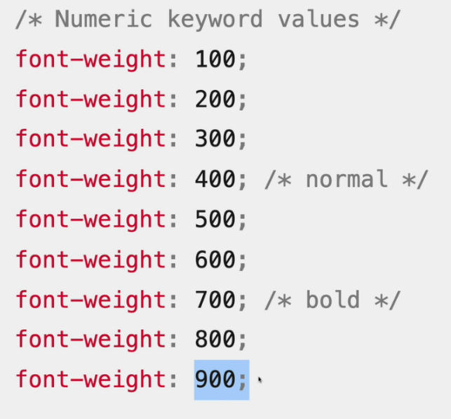

* **font-style: make text italic, normal, oblique etc..**
* **text-align: align text to the start, end, center, justify of the element which contains it**
  + **justify : aligns text to the left and right of the edges of its containers, except for the last line**
  + **justify-all: idem but also applies to the last line.**
  + **left and right are identical to start and end, except when the direction of the text is reversed**

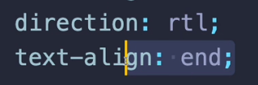

**If we set the direction of the text to be right to left, and align it to the end, then the text will be on the left side of the page.**

* **letter-spacing: change the spacing between the letters of a text, receives units.**
* **word-spacing: change the spacing between the words of a text, receives units.**
* **line-height: changes the spacing/height between the lines of a text**
  + **receives units**
  + **receives keywords like normal**
  + **or numbers. line-height: 2.5 means 2.5 times the default line height of the font size**

**62 – Adding Custom Fonts With Google Fonts**

* **As previously said, the website can only display the fonts that it has on the machine that its running, those that came preinstalled**
* **We can also import a custom font within our application, and it will be downloaded and used by the website, no matter whether the machine opening it has it or not.**

**We can import them in the css directly or:**

**In the cdh index.html:**

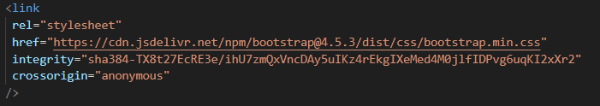

* **text-shadow:**
  + **adds the same text but with a certain offset below our original text**
  + **the bigger the blur, the less visible the text will be**
* **text-transform:**
  + **make text lowercase, uppercase, capitalize etc..**
* **text-decoration:**
  + **sets the appearance of decorative lines on our text**
  + **underline, dotted line etc**
  + **it is a shorthand property for text-decoration-line, text-decoration-color, text-decoration-style and text-decoration-thickness**

**Shorthand Properties: properties which are used to set multiple other properties at once**

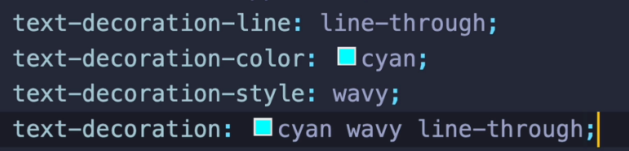

**The order in which we specify properties for a shorthand property doesn’t matter.**

**In this case, the last property is equivalent to the first 3.**

**If we wanted to clear the default underline which is present below links, we can do that with: text-decoration-line : none; OR text-decoration: none;**

**Id Selector**

* **We can also apply styles to a certain element by using its id**
* **In the css, we select that component’s id with a hashtag**

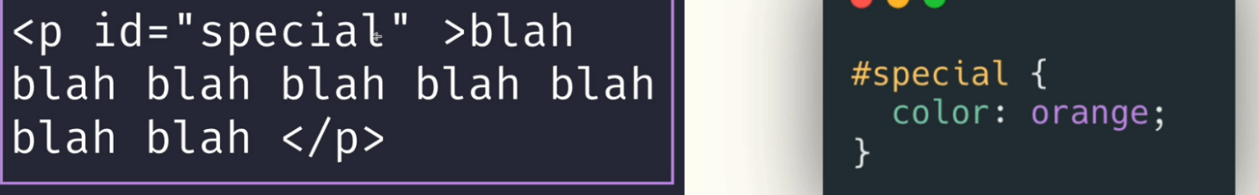

**Class Selector**

* **Define a class to an element and select that element using a dot and the classname**

 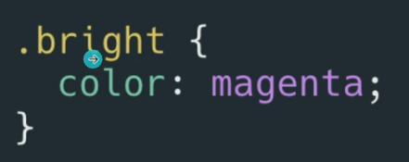

* **list-style-type: for ul or ol elements, allows us to change the little icon of each list element**
  + **the default one is disc**
  + **can also be set to none**
  + **can also be set to any text of our choosing like**

**list-style-type: “*”;**

* + **can also be set to an emoji if we have its code**

** for thumbs-up**

* **list-style-position: allows us to include or exclude the bulletpoint of a list element in the list element itself**
  + **By default, the point is on the outside of the list element**

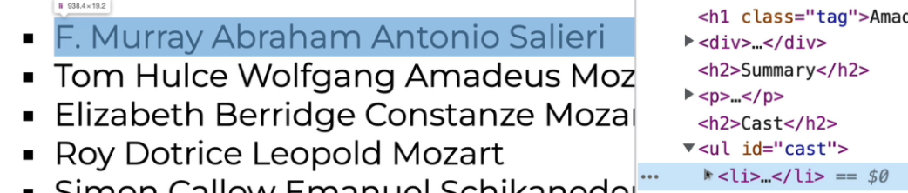

* + **But we can set it to be included by setting list-style-position: inside;**

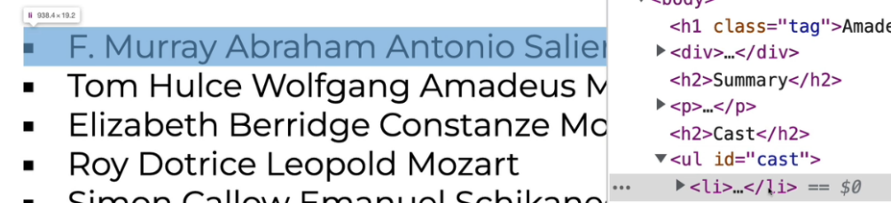

* **list-style-image: allows us to change an element’s marker to an image of our choosing**
  + **just like in cdh: care-section-do-don’t-component**

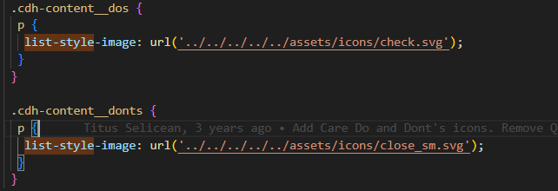

**What if we want to color all links which were visited by the user in a different color than the default one? Also change the cursor’s shape and the links cover when we hover a link.**

**we have to use a PSEUDO-CLASS. visited = appears in the browser’s history**

* **cursor: sets the image of our cursor**

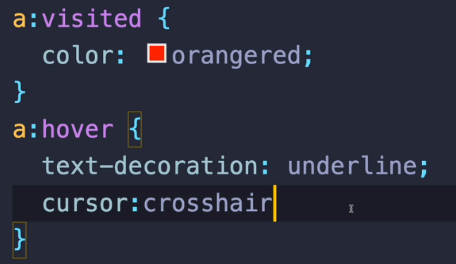

* **font: short-hand property used for setting the font family, font size etc…**
  + **not widely used**
  + **if used, it must include font-size and font-family**

**font-weight: 100;**

**font-size: 50px**

**font-family: Montserrat**

**⬄**

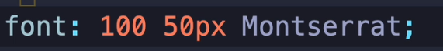

**10 – Selectors Pt 1**

**Universal Selector:**

* **marked with an asterisk**

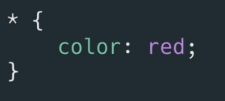

**Element Selector:**

* **just the tag of the element**

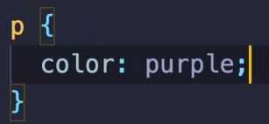

**Class Selector:**

* **marked with a dot followed by the class-name**

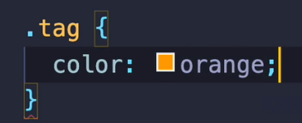

**Id Selector:**

* **marked by a hashtag followed by the element’s id**

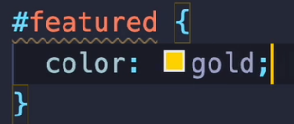

**Attribute Selector:**

* **selects elements based on the presence or value of certain attributes.**
* **syntax: *element* [ *attributeName* = *attributeValue*]**
* **this example selects all inputs which have their type set as email**

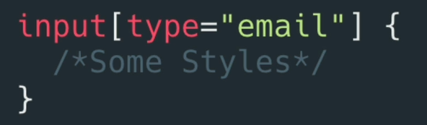

* **attribute selectors also let us match patterns.**

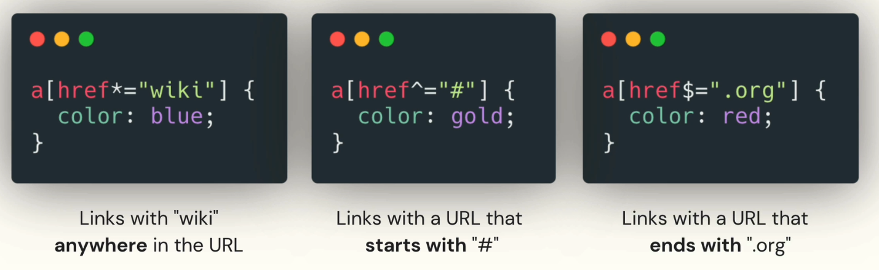

**Grouping Selectors:**

* **Multiple selectors (any types of selectors) can be grouped by just enumerating them in a list divided by commas.**

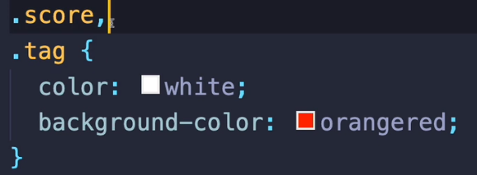

**Descendant Combinators:**

* **We can also target all selectors descendant of other elements:**
* **We need to separate the elements by spaces.**
* **This will target all spans present in a list item.**

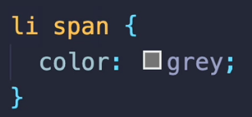

**If we had an example like this where our element has an id**

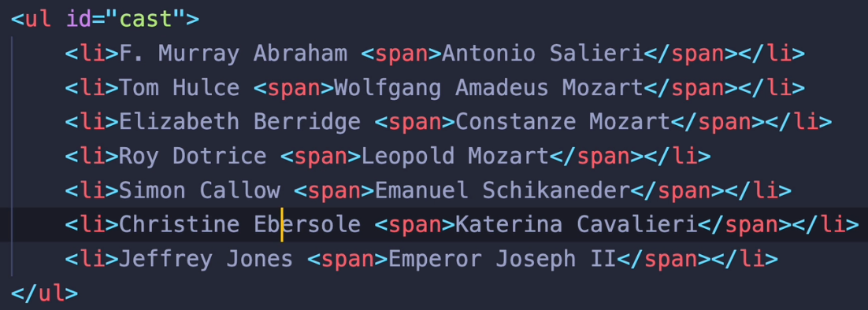

**it would be more convenient to use the id in order to be sure we don’t select other spans as well:**

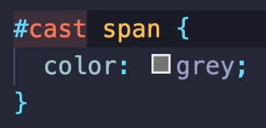 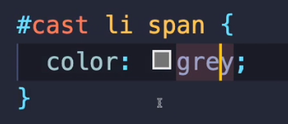

**In this example, spans are children of list items first and foremost, which in their turn are descendants of the ul element with the id cast. But that doesn’t matter. Our command targets any span which has a predecessor with the id cast, it doesn't have to be a direct relationship.**

**The second picture would also work, but is redundant.**

**Child Combinator**

* **Similar to the descendant combinator but only targets elements which are direct descendants of a certain element.**
* **We separate the elements by a right arrow.**

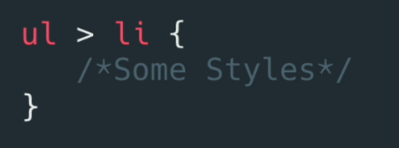

* **Works with all types of selectors**

**Compound Combinator**

* **allows us to combine class, id and element selectors**
* **we don’t use any spaces with this combinator and we think of every selector as being linked by an AND**
* **this example targets all div with a class of special**

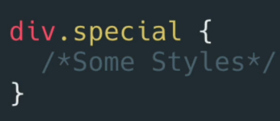

**Presented in 13 – Specificity and the Cascade**

**Adjacent Combinator**

* **selects elements that are directly after the first element, throughout all the elements**
* **In this case, only the first paragraph will be targeted**

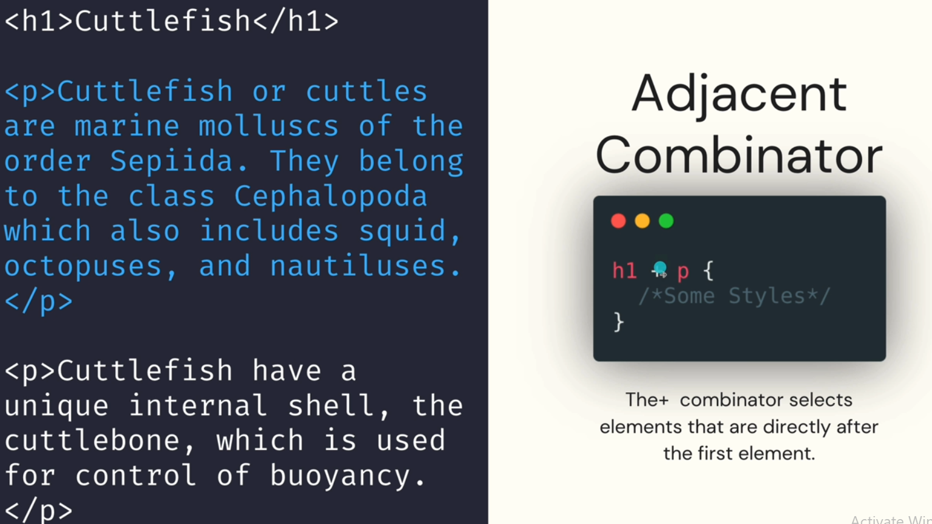

**Sibling Combinator**

* **Selects all siblings of an element**
* **Selects all elements that**
  + **have the same parent element as the 1st element**
  + **and come after (consecutiveness is not a requirement) the 1st element**
* **In this case, p elements coming before the h1 element will not be affected**

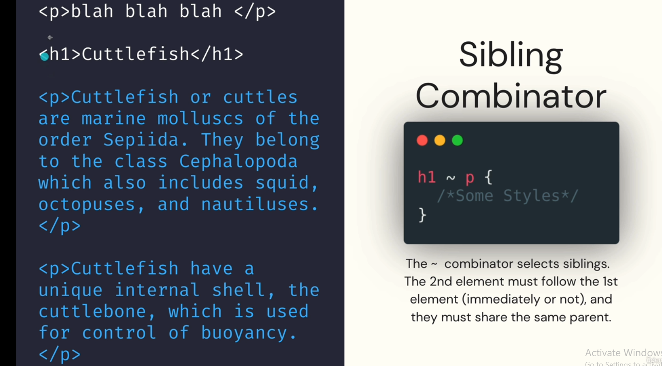

**11 – The box Model**

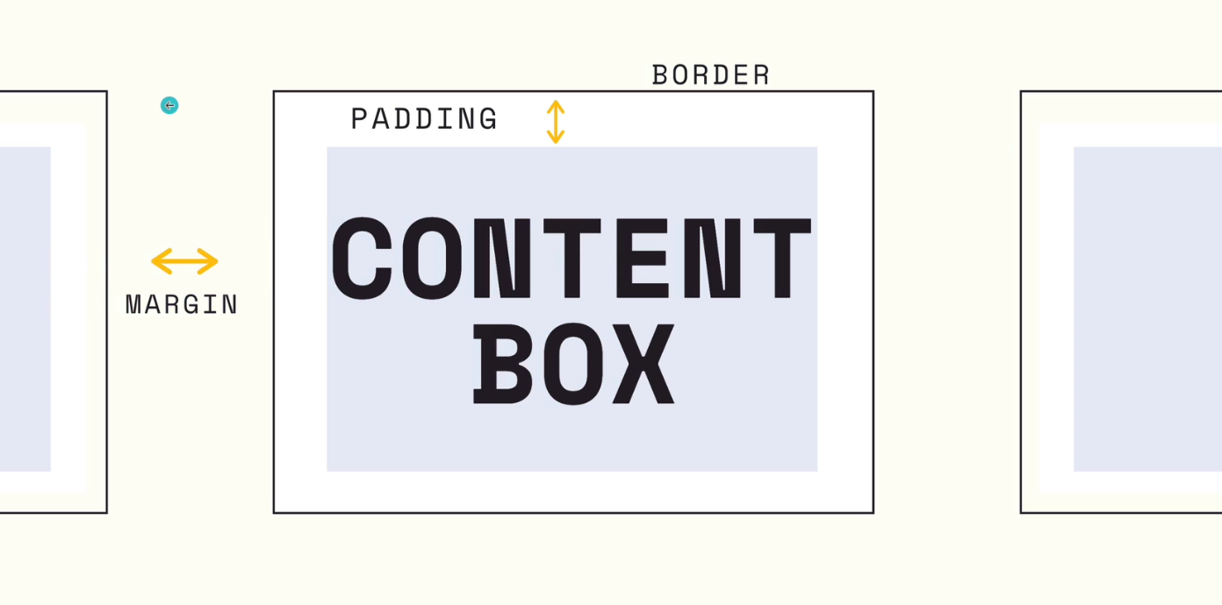

* **The box model states that each element in the browser is a box and we can control its properties, the most important of which are:**
  + **width**
  + **height**
  + **padding: the spacing inside (between the element itself and its border)**
  + **border**
  + **margin: the spacing outside (between the border and other elements)**

**Border**

* **border-color:** 
  + **color of the border, receives a color**
* **border-width:** 
  + **thickness of the border, receives an unit**
* **border-style:**
  + **solid, dotted etc…**

**Each one of these properties is a short-hand property for**

**border-*top/bottom/left/right*-color/width/style\***

* **border: shorthand property used to set all the previous ones**

**We can combine these such that a certain style is applied first and another style overwrites just one of the properties set**

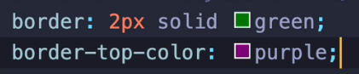

**The border color will be green initially, after which only the top color will become purple**

**We even have shorthand properties only for one direction of the border**



**This sets the width, style and color but only for the bottom portion**

**Width and Height:**

* **Lets us control the width and height of the box element**
* **Receives a unit.**
* **We can give a percentage to any of these properties which will represent a percentage of the container’s dimensions.**

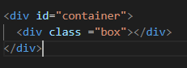 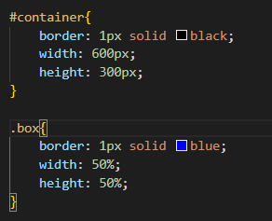

**results in** 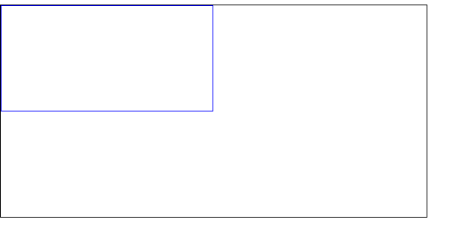

**Padding**

* **padding:** 
  + **spacing between the content box and its border**
  + **exists for all directions: top, bottom, left, right**
  + **padding is a shorthand property which will apply the padding in a clock-wise order**

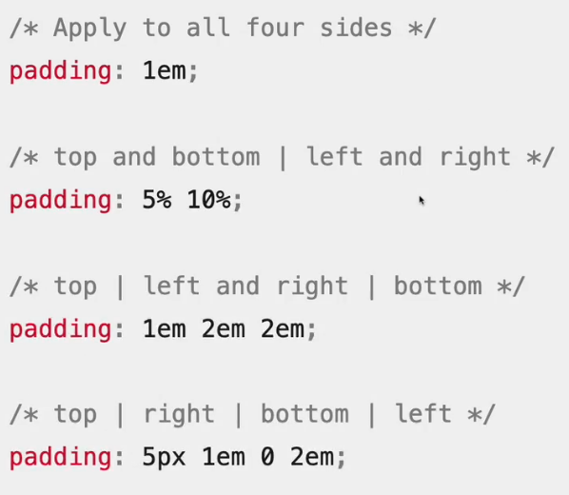

**Margin:**

* **margin:**
  + **spacing between the element’s border and other elements**
  + **exists for all directions: top, bottom, left, right**
  + **identical to padding when it comes to syntax**

**Alternate Box Model:**

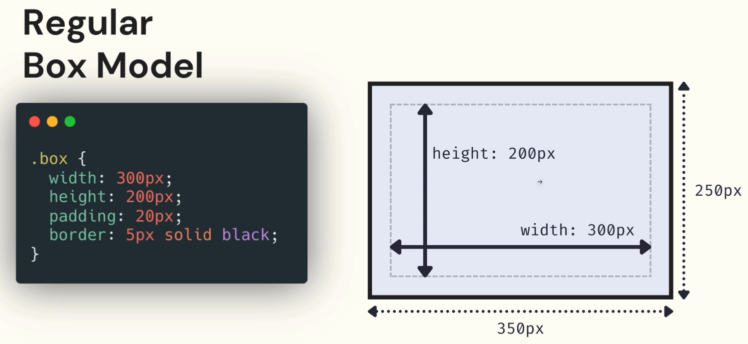

**Before, when setting the width and height of an element, we were targeting the content box, itself, the padding and border were additions.**

**But we can set the dimensions for the whole element using a property called**

**box-sizing: border-box;**

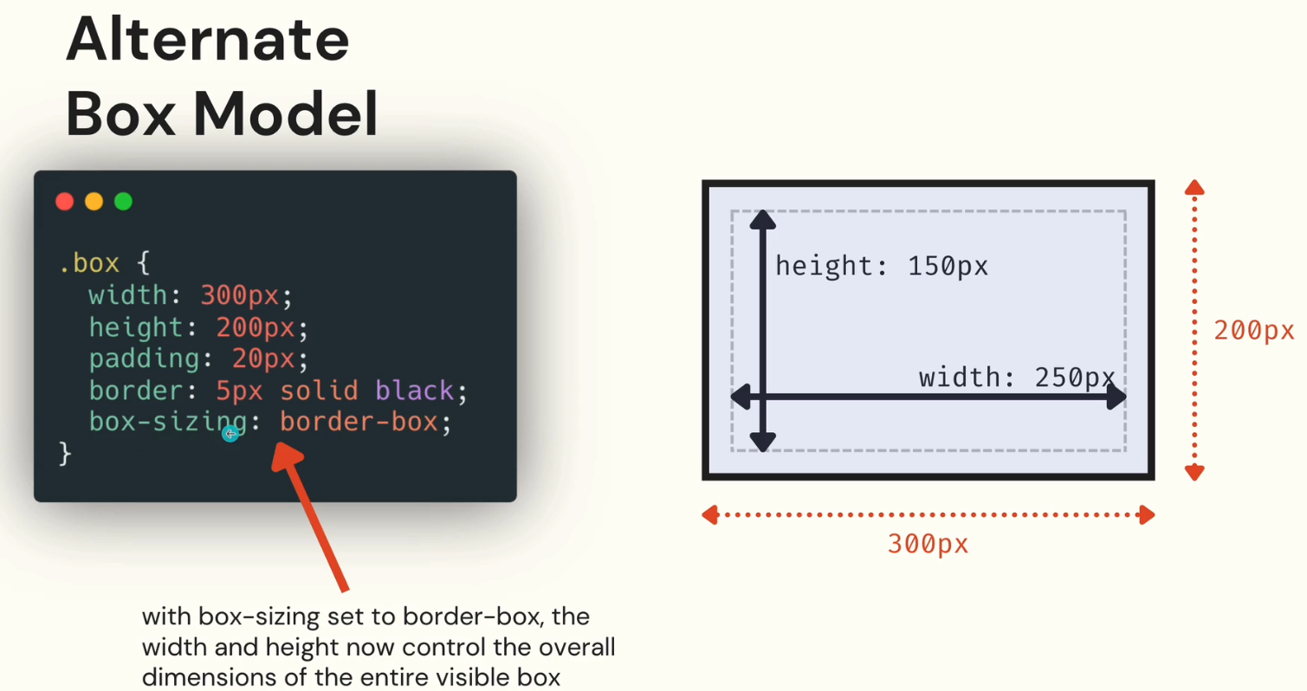

**So in this case, we set the width of the whole box to be 300px, with a padding of 20px and a border of 5. Then the browser will calculate that it needs 250px in width for the content box.**

**300 – 40 (20 padding on both left and right) -10 (5 border on both left and right) = 250px**

**Display:**

* **We can use the display property to set whether an element is treated as a block or an inline element**
* **As we know, spans are inline element. That means that a margin, will behave differently with it.**

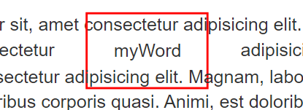

**In this example, we have a simple paragraph with a span inside it, wrapping the word “myWord”. We can see the span has a border, padding and margin added to it, but it doesn’t push the other elements away in the vertical direction. It overlaps them.**

**Inline element**

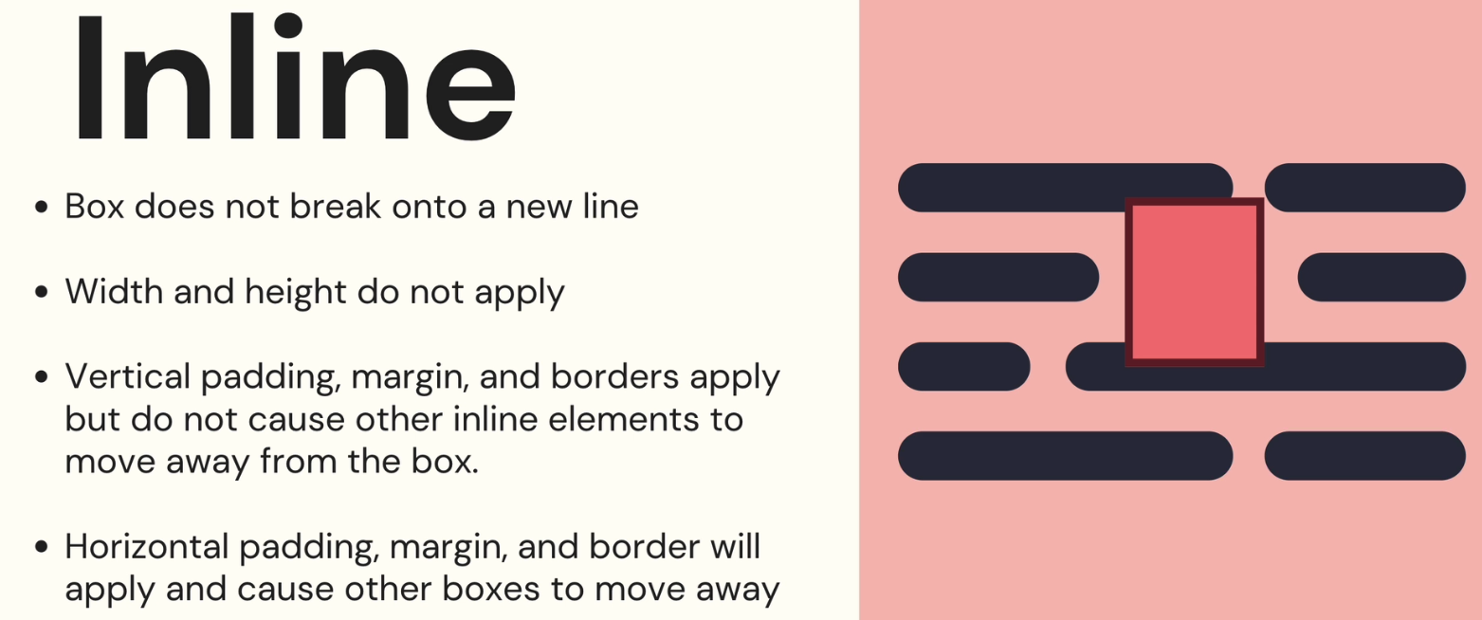

**Block element**

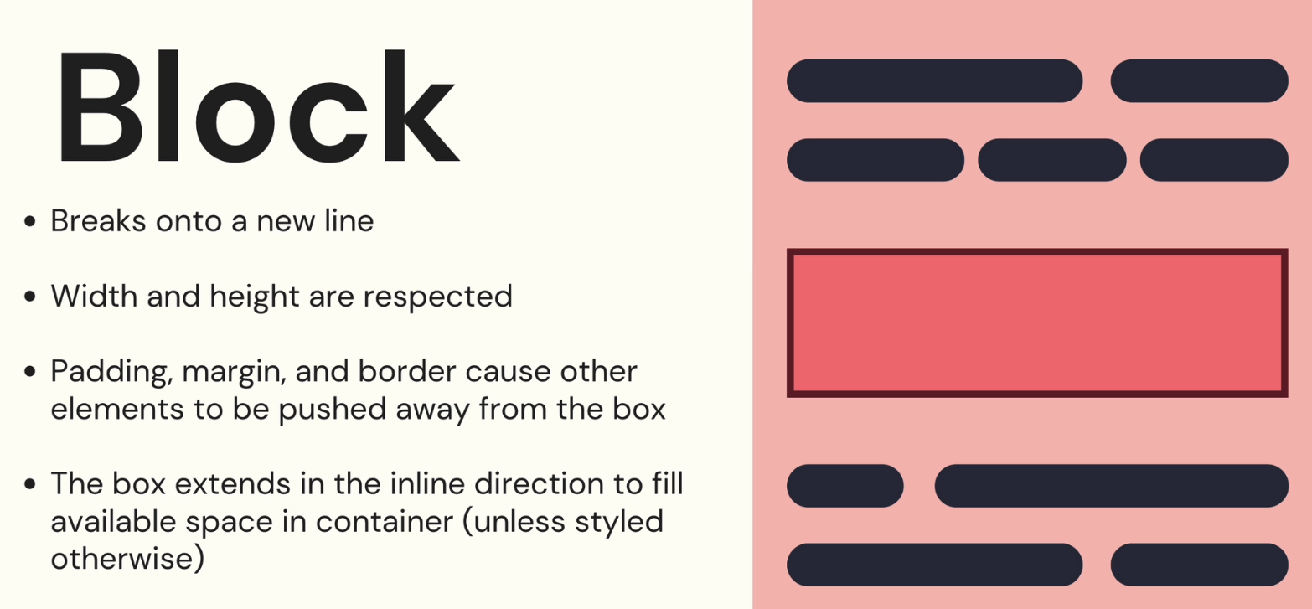

**Thus, we can treat our span as a block and result will look like this:**

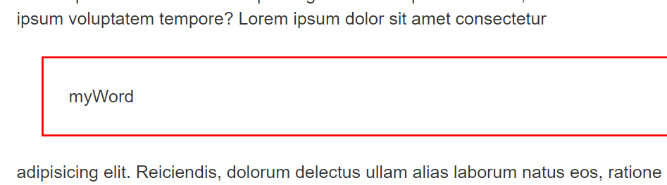

**There also exists a hybrid between these two types of displays.**

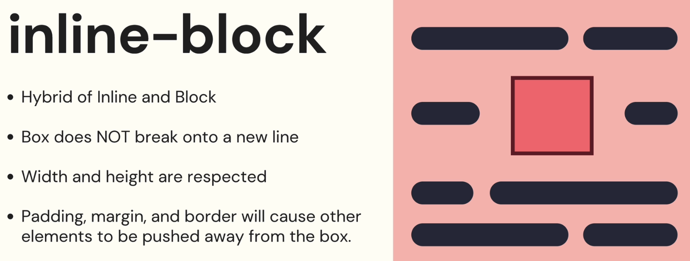

**Applying it to our span, it will cause the span to behave as a block, while still keeping that block inline with its surrounding elements**

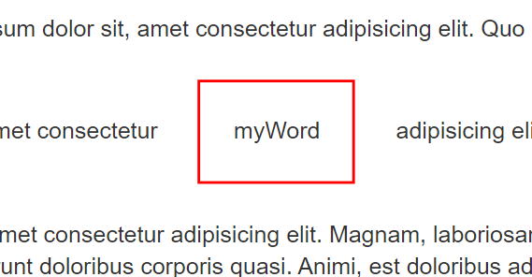

**Display: none;**

* **completely hides an element from the dom.**
* **it doesn’t get removed, it can still be seen in the dev tools, but it will not take any space in the layout of our page.**

**Margin**

* **the margin can also receive the auto value, which lets the browser decide how much space it should allow for the margin**
* **very useful if want to center an element horizontally**

**margin: 0 auto;**

* **margin : 0 auto;**
  + **will not center an element horizontally if the element doesn’t have a set width.**
  + **will not center an element if it is not a block element**

**Margin Collapsing**

* **Vertically, if we have two element one below the other, and each element has a margin for their top and bottom value, the margin-bot of the 1st element will not add with the margin-top of the 2nd element.**
* **In other words, the space between them will not represent the sum between those margins, but will represent the higher value between those margins.**
* **This is called margin collapsing;**

**div 1 with margin-bottom :20px**

**div2 with margin-top:30px;**

* **Space between them = 30px;**
* **Also, if the two elements have negative margins, the BIGGER ABSOLUTE VALUE will win**
* **This is not true for elements displayed horizontally. In a horizontal layout, the space between the 2 elements WILL represent the sum of the right margin for the 1st element and the left margin of the 2nd element.**
* **This only applies in the FLOW LAYOUT (the default one, not flexbox or grid)**

**MAX-WIDTH and MIN-WIDTH**

* **used to set the maximum and minimum allowed width for an element**
* **We can say an element has a width of 50% of its container’s element but also it shouldn’t be less than 200px.**

**width: 60%;**

**min-width: 200px;**

* **border-radius:** 
  + **used to round the corners of an element’s outer border edge**
  + **a percentage given to this property, is relative to the width and the height of that very element ( sidenote: a border-radius of 50% applied on a square will produce a perfect circle )**
  + **it is also a shorthand property for the properties targeting each corner:**
    - **border-top-hand-radius**
* **box-shadow:**
  + **similar to text-shadow**

**Useful site for radius, shadow etc… generator :**

[**https://www.cssmatic.com/box-shadow**](https://www.cssmatic.com/box-shadow)

* **overflow:**
  + **specifies what should happen when the content of an element is too big to fit in its box**
  + **main ones are visible, hidden and scroll**
  + **overflow-x and overflow-y to control a certain direction**
* **object-fit:**
  + **specifies how the content of an image or video should be resized to fit its container**
  + **cover is the most used and clips the image if it doesn’t maintain its aspect ratio.**

**106 – Working with Pseudo-classes**

* **a keyword added to a selector representing a certain STATE of that element**

**Useful ones**

**For input elements:**

* **enabled / disabled**
* **valid / invalid**
* **required / optional**

**Location Pseudo-classes (for link elements):**

* **visited / link (AKA not visited)**

**Tree-structural pseudo-classes:**

* **start with a colon**
* **target elements with a specific location in the document tree**
* **empty: for elements with no children**
* **first-of-type / last-of-type: first/last element of its type among a group of siblings**

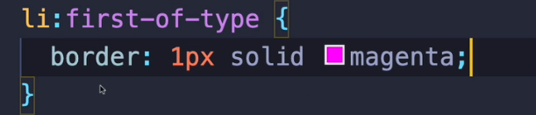

**This will select the first li element, among all the groups of li elements in our page.**

* **nth-of-type():** 
  + **selects the nth element, n being specified as a parameter, n start from 0**
  + **nth-of-type(2) : 2nd element**
  + **nth-of-type(2n) / nth-of-type(even): even elements**
  + **nth-of-type(2n+1) nth-of-type(odd): odd elements**
* **first-child/last-child: targets elements which are the first/last of its siblings**

**User action pseudo-classes**

* **hover**
* **active (for instance, when you click on a button and don’t release the left click)**
* **focus (an element is focused after the user has clicked or tapped it)**

**Pseudo-elements**

* **start with 2 double colons.**
* **pseudo-elements are keywords added to a selector which lets us style a particular part of an element**
* **example:**

**p::first-line {**

**color: red;**

**}**

* **will make only the first line of the paragraph red**
* **first-letter**
* **placeholder**
* **selection: applies styles to whatever is selected**

**Specificity**

* **When multiple rules with different selectors apply to the same element, which one wins out?**
* **CSS has a set of rules which define which selectors have a higher specifity**

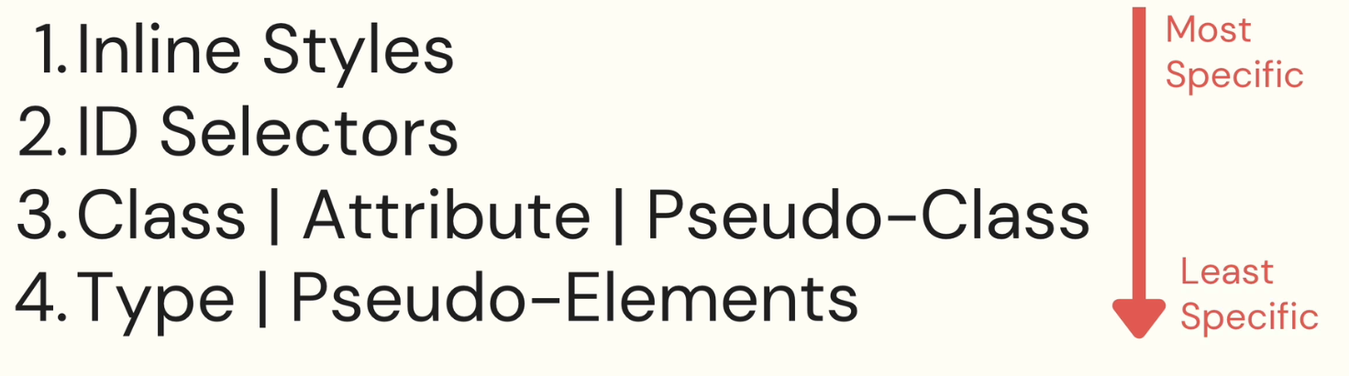

**Inline Styles are the styles applied directly onto the html element ( directly in the template)**

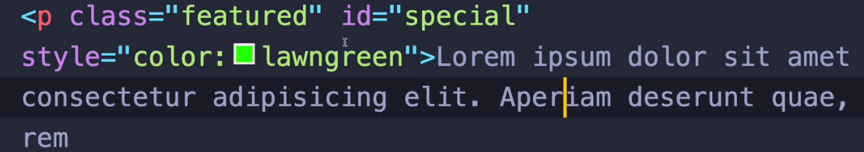

**Calculating Specificity Values**

* **What if we have multiple selectors combined ( using combinators), which will win?**
* **The signs used for combinator ( > ~ etc… don’t matter, we only look at the type of selector)**
* **Hover over a selector in VScode to know its specificity**

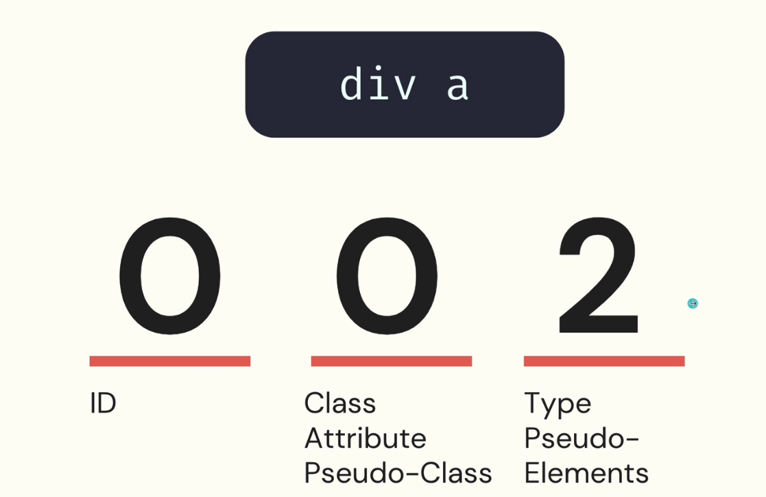

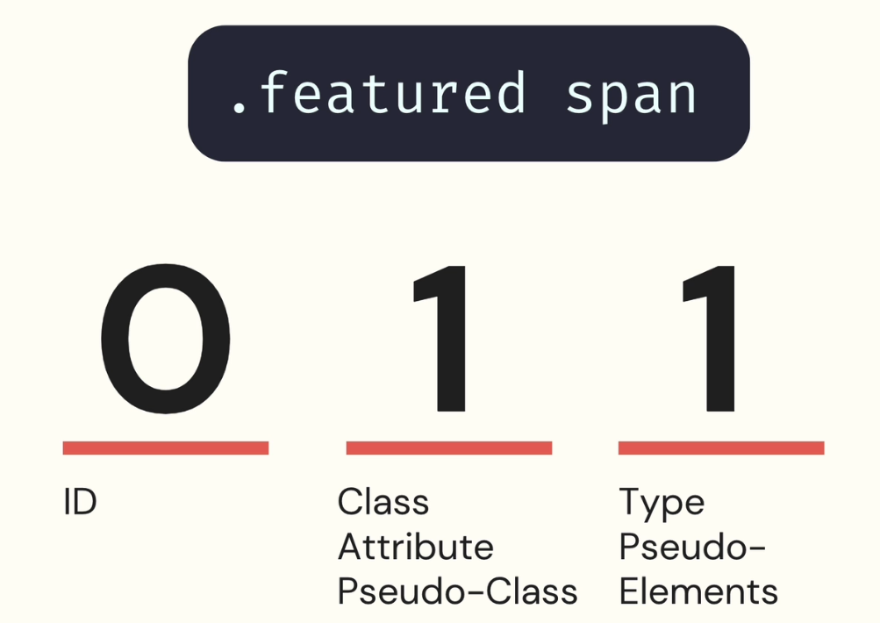

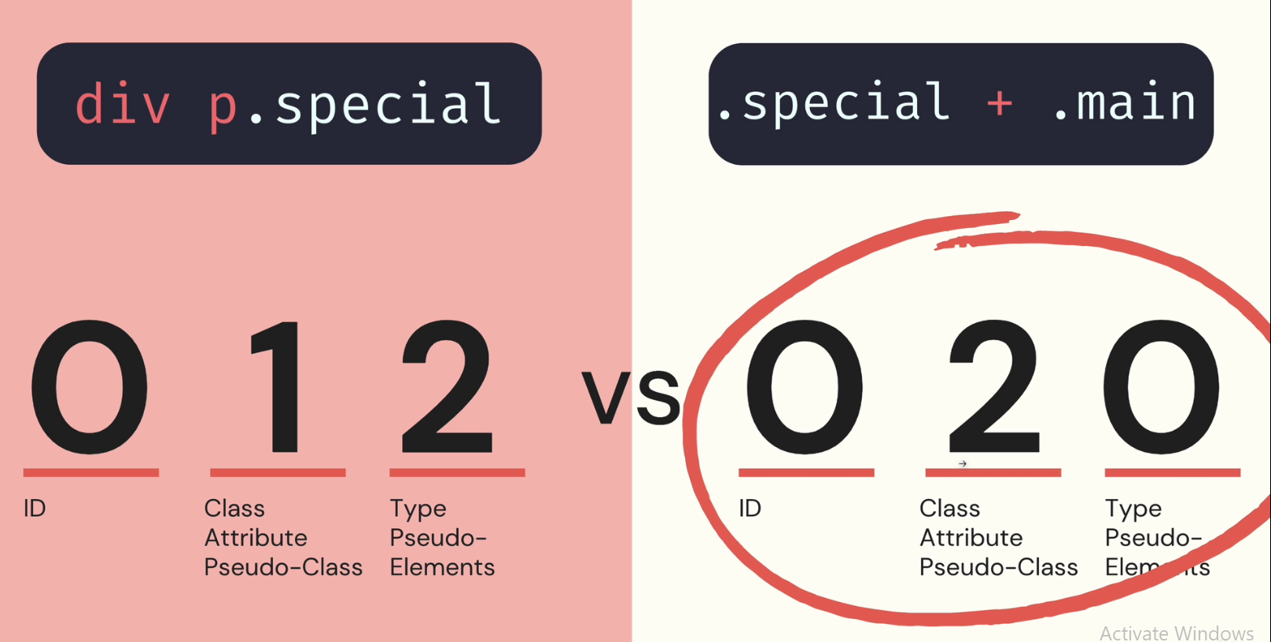

* **The browser compares the digits on the same position, starting from left to right until it finds a bigger digit on the same position**

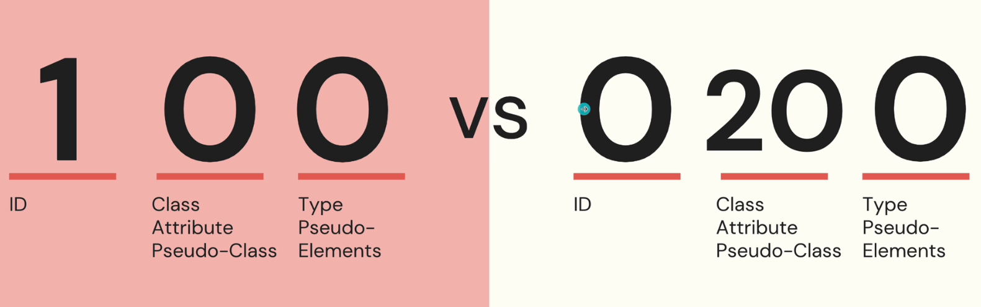

* **The first one wins**

**Cascade**

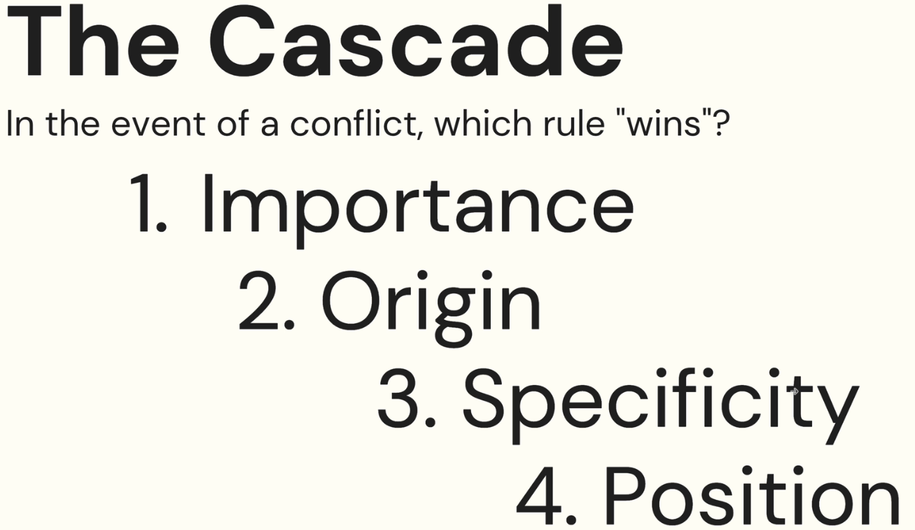

* **Whenever we write CSS, the code enters the cascade. The further down our code falls in the cascade, the less likely it is to end up as the final style**
* **We first compare importance, then origin, then specificity and finally position**
* **Importance**
  + **setting code !important makes it rise to the top of the cascade and ignores the rest of the cascade’s properties**
  + **Transitions and Animations have special importance to ensure they are applied**
* **Origin**
  + **where does the code come from? Is it browser CSS or our CSS?**
  + **Website CSS (our code) >> User CSS >> Browser CSS (default styles)**
* **Specificity previously discussed**
* **Position**
  + **The latest defined rule will win.**

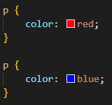

* + **Importance, Origin and Specificity are all the same => check for position => the paragraph will be blue**

**15 – CSS Units**

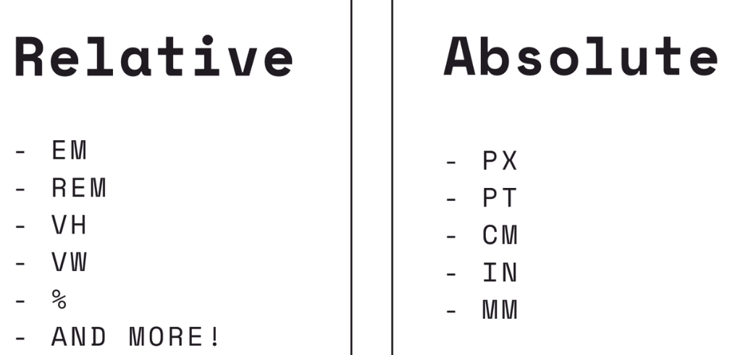

**Percentages**

* **Sometimes, they are relative to their parent and sometimes they are relative to themselves**
* **width: 50% => half the width of the parent**
* **line-heigth: 50% => half the font-size of the element itself**

**REM**

* **root ems**
* **relative to the root element’s font size**
* **if the root font size is 20px => 1 rem = 20px, 2 rem = 40px …**
* **In most browsers, the default font size is 16 pixels**

**EM**

* **ems are relative to the font size of its parent element**
* **1em = font-size of parent | 2em = 2* font-size of parent …**
* **Should be used with care when nesting multiple elements. Each element will progressively get smaller**
* **If the parent doesn’t have a set font size => 1 em will be the font-size of the element itself (be it default or inherited)**

**VW and VH**

* **viewport width and viewport height**
* **both are units relative to the viewport (the visible area of your browser window)**
* **1vw is 1% of the width of the viewport**
* **1vh is 1% of the height of the viewport**
* **100vw and 100vh is the entire viewport**

**Unit Tips:**

* **Pixels:**
  + **Avoid pixels for font-sizes. They don’t scale and aren’t responsive**
  + **They are useful for small details like borders, shadows etc…**
* **REM and EM:**
  + **Good choice for font-size**
* **Percentages:**
  + **useful for defining layouts/ widths/ heights**
* **VW and VH:**
  + **used for larger layout concerns**

**Float:**

* **originally intended for newsletter articles with an image with text flowing around it (floating images inside blocks of text)**

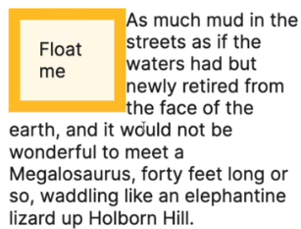

* **it became widely used for creating different layouts throughout the page**
* **returned to its original purpose after the introduction of flexbox and grid**

**For a template with an image and a paragraph:**

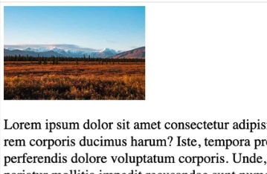 **Setting float to left or right, for that image, will make the text float around it.**

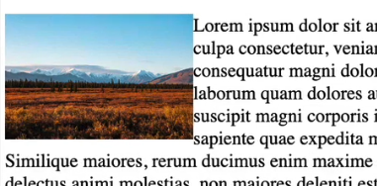

* **The image gets placed on the left/right of its container element**
* **If we wanted to set a margin-right around the image we could**



* **But adding a margin left to the paragraph will not work as expected**

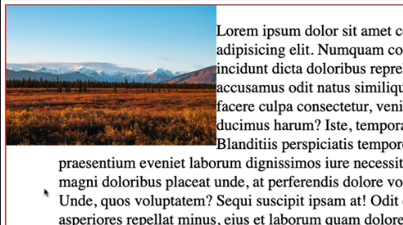

* **The margin gets applied to the paragraph, but not where the paragraph meets the image. That is because, when we float something, it’s taken out of the flow of the document.**

**17 – Background Gradient Filters**

* **background-image: set an image url, relative to your file location**

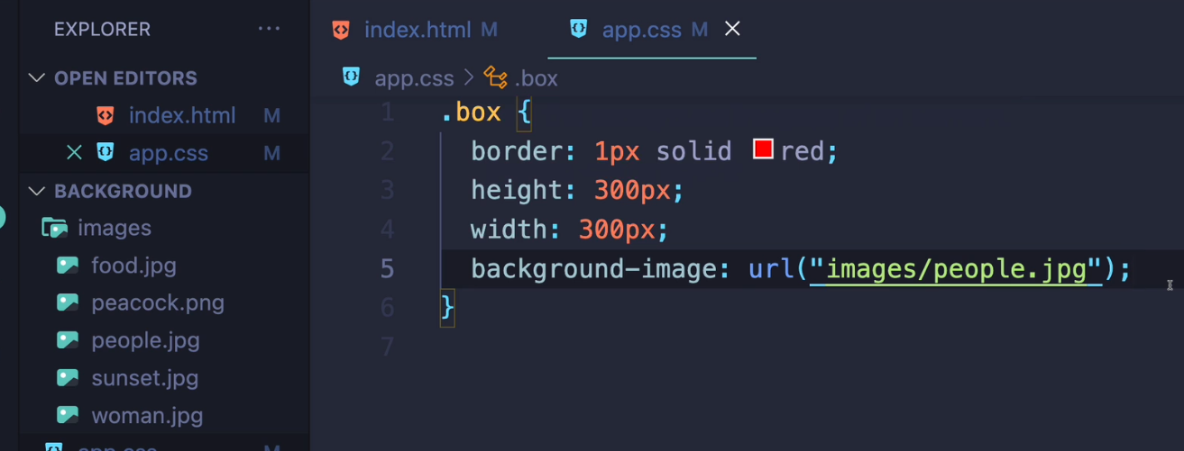

* **We can set multiple background images**

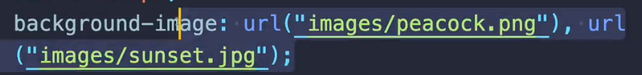

**This will first place the sunset image and then place the peacock image on top of the sunset image**

* **since we made our box so little, an image bigger than our container will be kept at its original resolution and only have a cropped part of it displayed while an image smaller than our container will be displayed repeatedly in order to fill up the whole box**

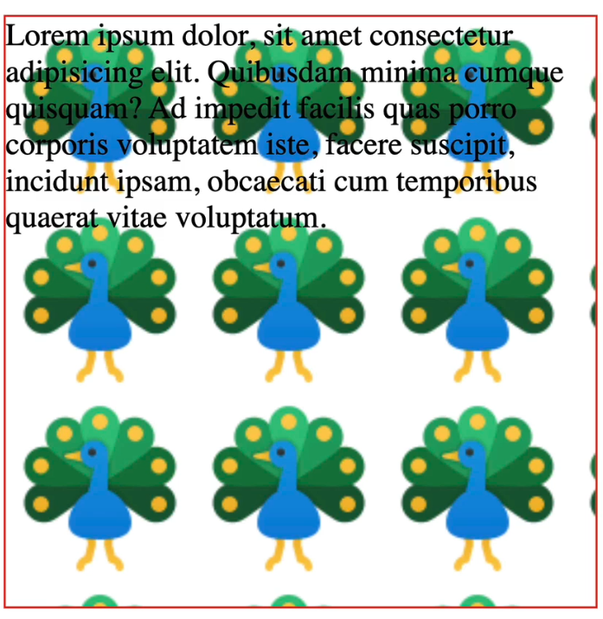

* **a background-color applied to the box will be visible if the background-image has a transparent background as the image gets placed on top of the background**
* **background-repeat:** 
  + **comes into play when the image we set on the background doesn’t cover the whole space of the container**
  + **As we saw, an image smaller than the container will repeat itself to ensure the whole container is covered**
  + **background-repeat helps us control this functionality and can be set to non-repeat**

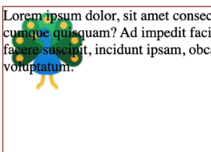

* **possible values**
  + **repeat: default value, repeats the image**
  + **non-repeat: stop the repetition**
  + **repeat-x: only repeats horizontally**
  + **repeat-y: only repeats vertically**
* **background-size:** 
  + **useful when we want our image to be sized down/up to the size of the container**
  + **background-size: contain**
    - **scales the image as much as possible without cropping or stretching it**
    - **if the image is then smaller than the container, we will get image tiling (the repetition of the image)**
    - **basically we will see the whole image within the container, but it might repeat**
  + **background-size: cover**
    - **scales the image(while preserving its ratio) to fill the container such that there are no empty spaces(so full width and height of the container). If the ratio of the background differs from the image’s ratio, then the image gets cropped.**
  + **we can also pass percentages**
    - **background-size: 50% 50% will make our image take 50% width and 50% height of the container. Ofc, that means the image will start to tile.**
* **background-position:**
  + **used to position the background image relative to its container**
  + **we can use the keywords: top, left, bottom, right, center or we can use units**
  + **bottom: the image’s bottom border gets placed on the container’s bottom border and then the image gets rendered**
    - **same for the other keywords**
  + **there are syntaxes for passing 2, 3 and even 4 parameters**
    - **2 parameters : keywords : top left | bottom left etc …**
    - **3 paramters: 2 are keywords, the other one is an offset to the preceding value**
      * **bottom 100px left**

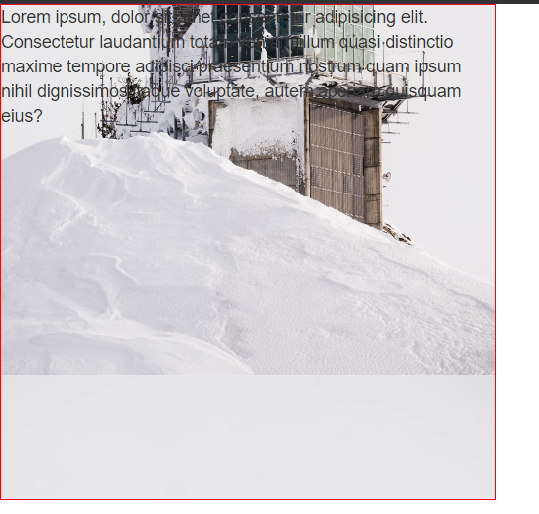

**Start from the bottom left corner, but the bottom also has an offset of 100px**

* + - * **bottom left 100px**

**Start from the bottom left corner, but the left also has an offset of 100 px**

* + - * **In any of these 2 previous cases, if the image gets smaller then the container, it will start to tile**
    - **4 parameters :** 
      * **1st is keyword, 2nd is offset for 1st, 3rd is keyword, 4th is offset for 4th**
* **background-clip:**
  + **controls where the element’s background extends: to the content-box, to the padding-box or to the border-box**

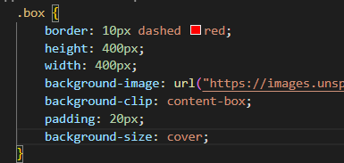 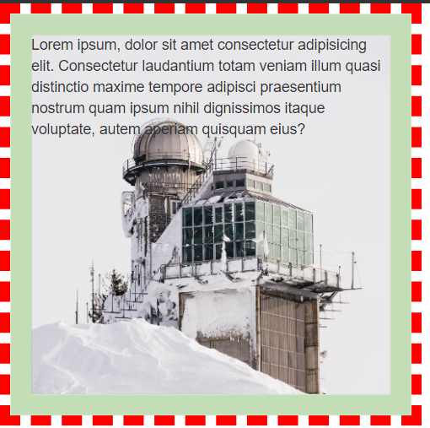

**In this case, I added some padding on all sides so we can see the image only covers the content box, as I’ve set it.**

**Gradients**

* **An object of type gradient is a special type of image**
* **linear-gradient:** 
  + **represents a transition between 2 or more colors along a straight line**
  + **background-image: linear-gradient(cyan, magenta);**

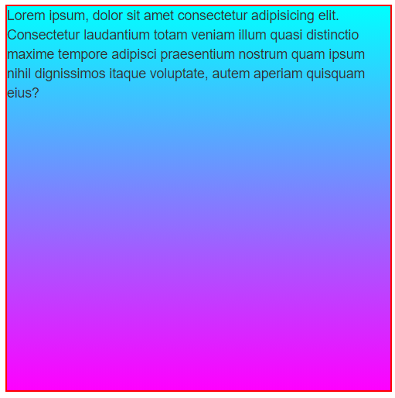

**create a gradient which starts at cyan and ends at magenta, and goes top-> bottom ( default behaviour)**

* **we can use keywords like to left, to right top to specify where to end**



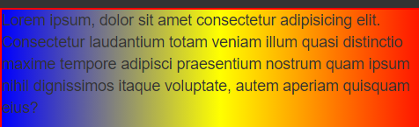

* **we can also specify a degree angle. The point of reference for 0 degrees will be the bottom border, with each degree tilting right.**



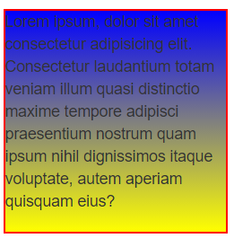

* 

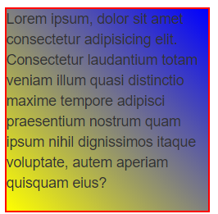

* **180 degrees ⬄ to bottom**
* **We can apply multiple gradients and they will stack on top of one another. Search it online 😊**
* **Also, we can specify where each color of the gradient should start**



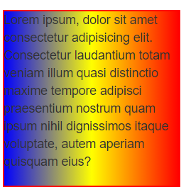 **This just splits the colors evenly**

**but this**



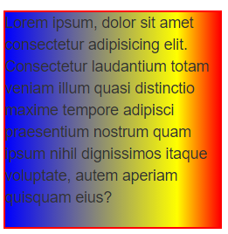**It goes to the left so it starts at the right border. Red will be first, yellow will start at 20% of the way and then blue will come.**

**Useful site for different gradients:**

[**https://uigradients.com/#eXpresso**](https://uigradients.com/#eXpresso)

* **radial-gradient:** 
  + **still a transition between 2 or more colors, but it radiates outwards from a point of origin**
  + **we can control the shape of a radial gradient:**



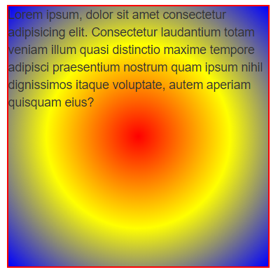 **circle is the default if the container is a square**

* **compared to ellipse**



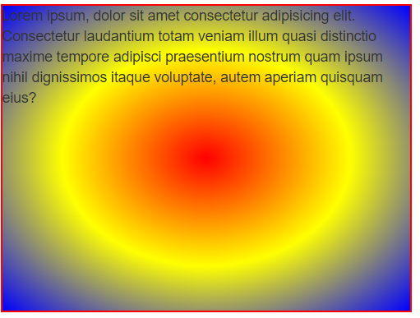

* **we can also position the geometric shape**



* **we can also specify where the colors should start with percentages, just like we did with linear-gradient**
* **conic-gradient:** 
  + **color transitions rotated clock-wise around a center point**



**f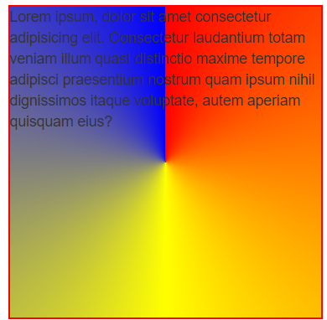==>** 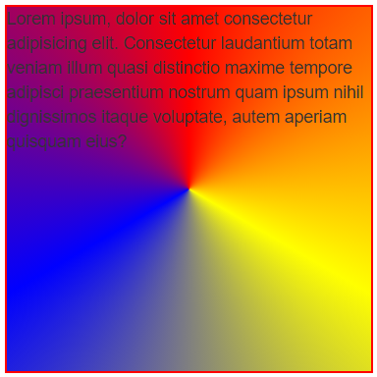

**Trick to have a smoother transition at its end: start and end with the same color. So add a fourth color of red to our code above.**

* **We can also use stops (percentages) for every color**
* **We can also modify its rotation**
* **Can be used to construct pie-charts**
* **repeating-linear-gradient:**
  + **it has a linear-gradient which it then keeps repeating until it covers the container**
  + [**https://developer.mozilla.org/en-US/docs/Web/CSS/gradient/repeating-linear-gradient**](https://developer.mozilla.org/en-US/docs/Web/CSS/gradient/repeating-linear-gradient)
* **same for repeating-radial-gradient and repeating-conic-gradient**
* **background:**
  + **shorthand property for multiple background properties**

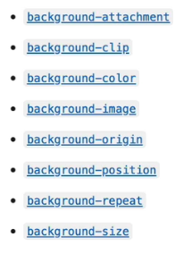

* + **kind of confusing, easier to write them 1 by 1**
  + **one main rule, setting background-size can be included only if we also set background-position and the syntax is position/size like this: center/70%**
* **filter:**
  + **can also be applied to elements, not only to the background**
  + **sets different built-in filters**

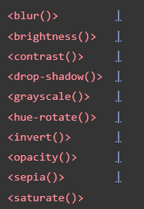

* + **These filters can be chained:**



**Position:**

**Static:**

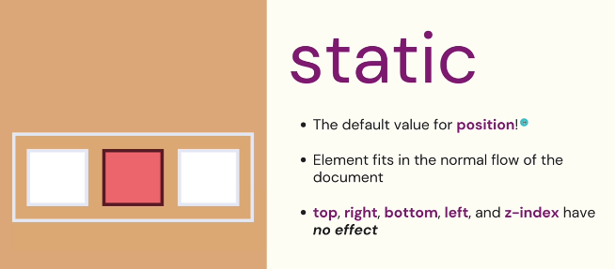

**Relative:**

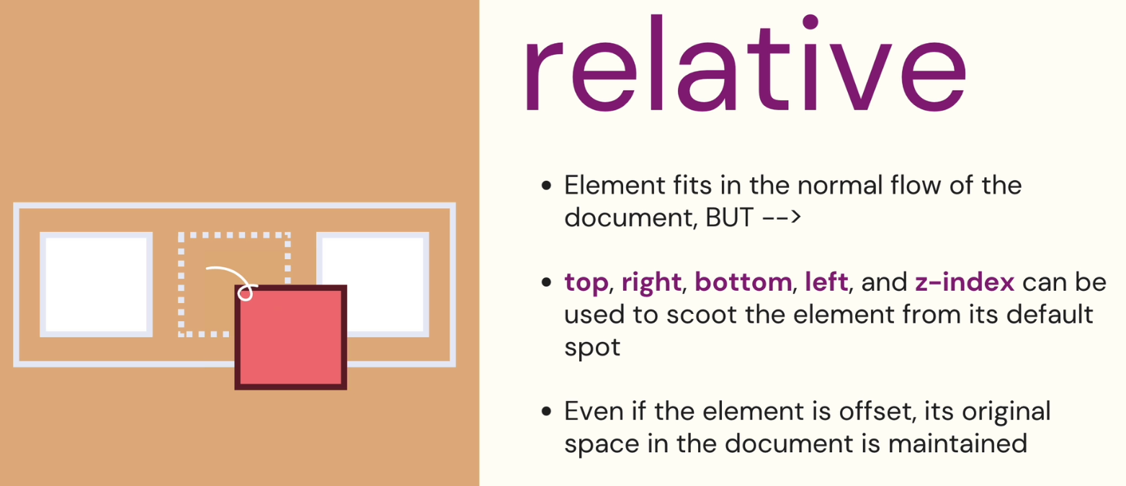

* **the relative property doesn’t change the element’s position until we change its top, right, bottom or left properties**
* **the properties top, bottom, left and right allow us to move an element based on the top edge of that element.**
* **even if that element is moved, the white space “left behind” will not be filled.**
* **z-index:**
  + **specifies the elevation of an element**
  + **only works on elements that are positioned AKA not static**
  + **if 2 elements are overlaying, the element with the bigger z-index will be on top**

**Absolute:**

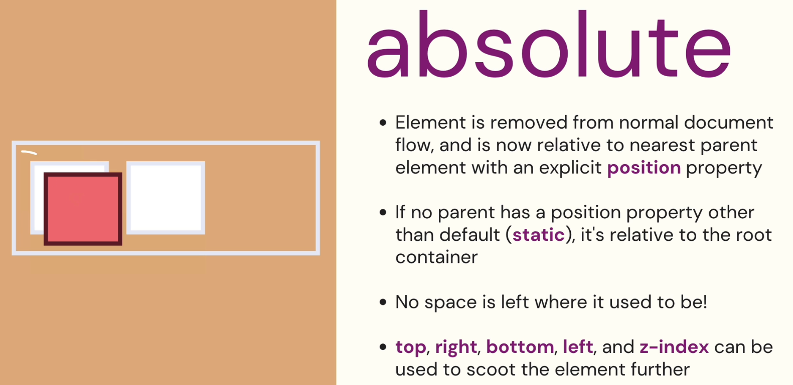

**Fixed:**

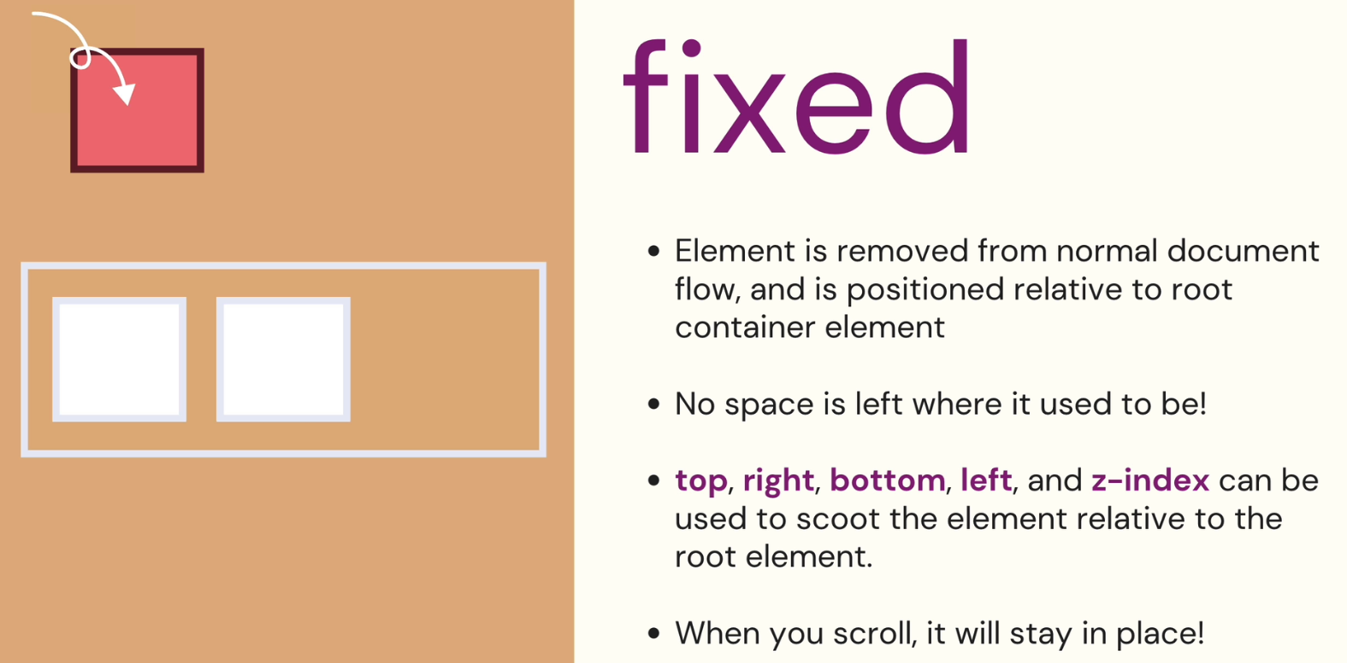

* **It’s basically an absolute always relative to the root container, which will stay in place when scrolling.**

**19- Transitions and Transforms**

* **2 main types of animations in CSS**
  + **Transitions**
    - **Transitions from state to another**
  + **Keyframe animations**
    - **The animations in which you can set all the step-by-step individual checkpoints in your animations (this will turn red at 1 sec, then get bigger, then be blue etc …)**

**Transition syntax:**



**In this example**

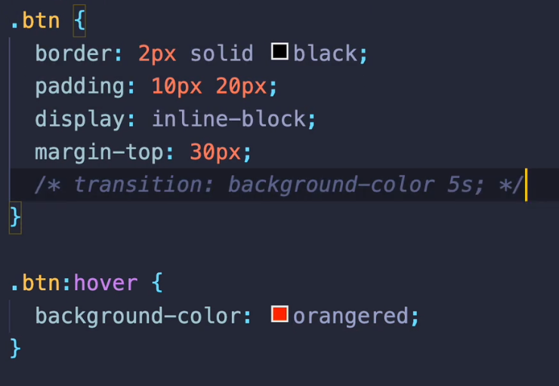

**We simply say what property we want changed and how long it should take. During those 5 seconds of hovering, the button will progressively get more red.**

**This simply says “Any element with the btn class, everytime its background color changes (no matter how it changes, it could be changed by javascript or using any other way) that change will have a transition of 5 seconds”**

**If we were to move the transition: background-color 5s; to the hover code, that would mean**

**“Only when we hover, we want the background color to have a transition of 5 seconds while changing”.**

* **We can chain as many transitions as we want by separating them with a comma**



* **We can even target all transitions (so all changes of properties from one state to another)**

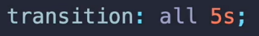

**Timing functions:**

* **Represent the 3rd parameter we can pass to a transition**
* **Sets are intermediate values are calculated for properties affected by a transition**
* **the default is ease ( starts slow, increases in velocity towards the middle and ends slow)**
* **Read the other values on the website but the most useful ones are the variations of ease and the steps and linear (which makes the transition have a constant velocity)**

[**https://developer.mozilla.org/en-US/docs/Web/CSS/transition-timing-function**](https://developer.mozilla.org/en-US/docs/Web/CSS/transition-timing-function)

* **The fourth parameter passed to a translation is a delayed expressed in seconds which delays the start of the transition**

**Animatable properties**

* **Not all CSS properties can be animated, their list is here**

[**https://developer.mozilla.org/en-US/docs/Web/CSS/CSS_animated_properties**](https://developer.mozilla.org/en-US/docs/Web/CSS/CSS_animated_properties)

* **Certain properties, even though animatable, have a great impact on performance.**

**A bad thing to do is move an element back and forth on the screen by modifying its margin. Transform is much more suited and efficient in this regard.**

* **We first need to understand how browser rendering works**

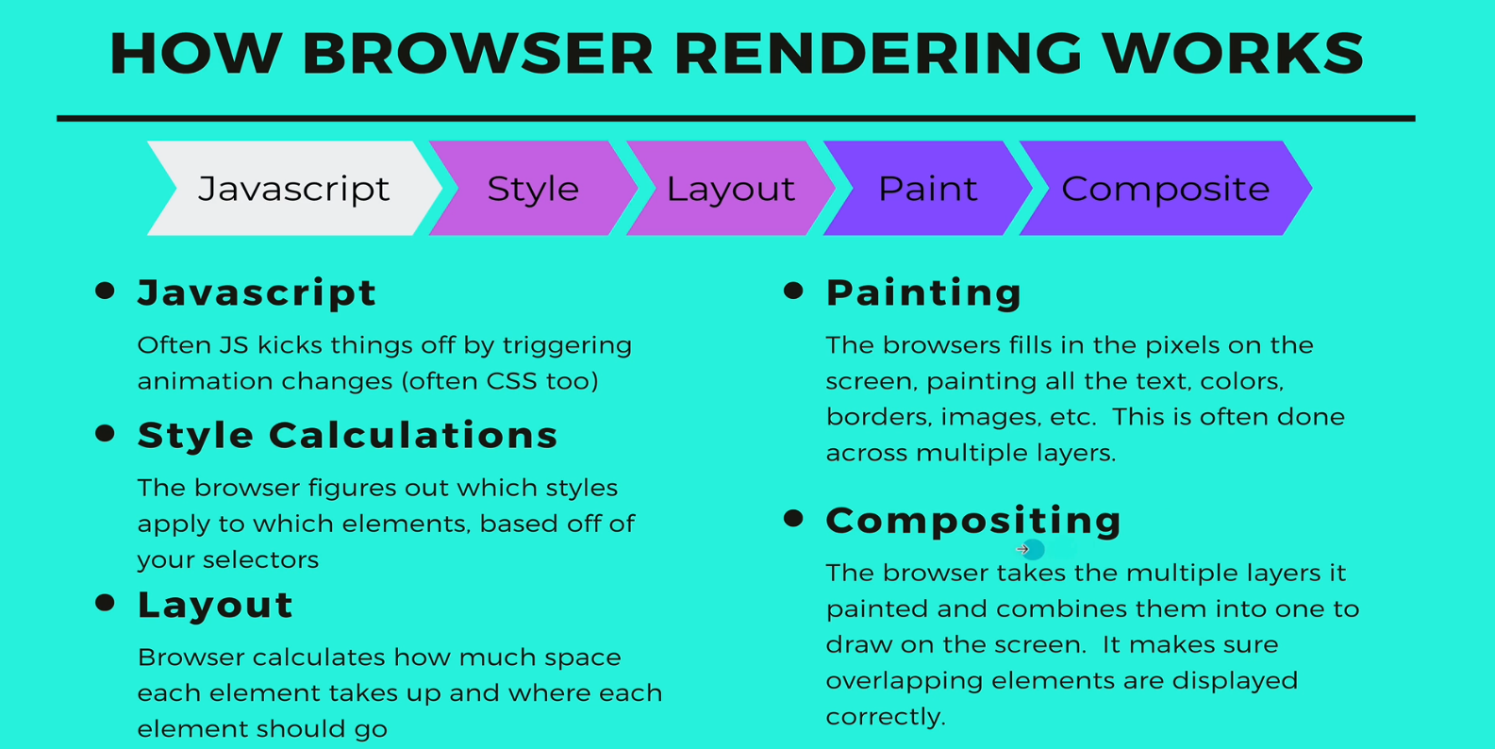

1. **Something like margins or widths and heights is taken into account during the layout stage. So if we animate it, we force a layout step -> a painting step -> a compositing step each time.**
2. **Changing the background-color or something else only triggers the painting and compositing steps.**
3. **Opacity and Transform (the 2 properties which are “most animatable”) only trigger a re-composition.**

* **transform:**
  + **allows us to rotate, scale, skew (tilting an element) or translate an element**

**or even alter its 3d form with things like matrix, perspective etc**

* + **all the transform operations have their center of reference in the middle of the targeted elements**
  + **transform operations can also be chained, by dividing them with a space**



* **transform-origin:**
  + **changes the center of origin for an element’s transformation**

**Flexbox**

* **a layout method for laying out items in rows or columns**
* **allows us to dynamically distribute space across elements of unknown sizes (basically, we don’t have to specify which elements should take us 10, 20%... percent of the screen etc, flexbox will do it for us)**

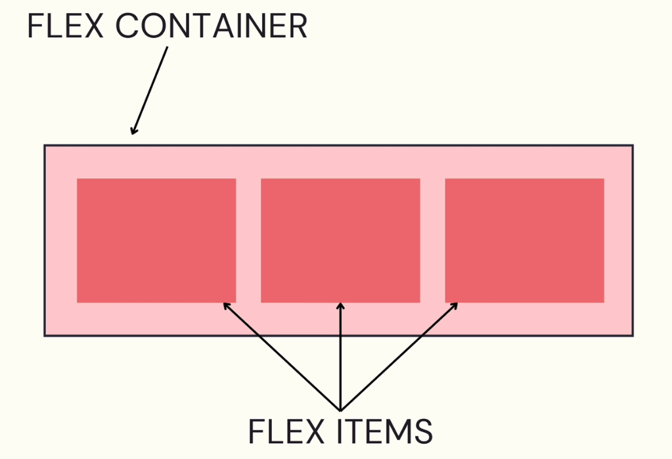

**In order to use flexbox, we have to declare a container by setting its display: flex. The items within that container will then be flex items.**

**In flexbox, there are 2 main axis that we have to keep in mind:**

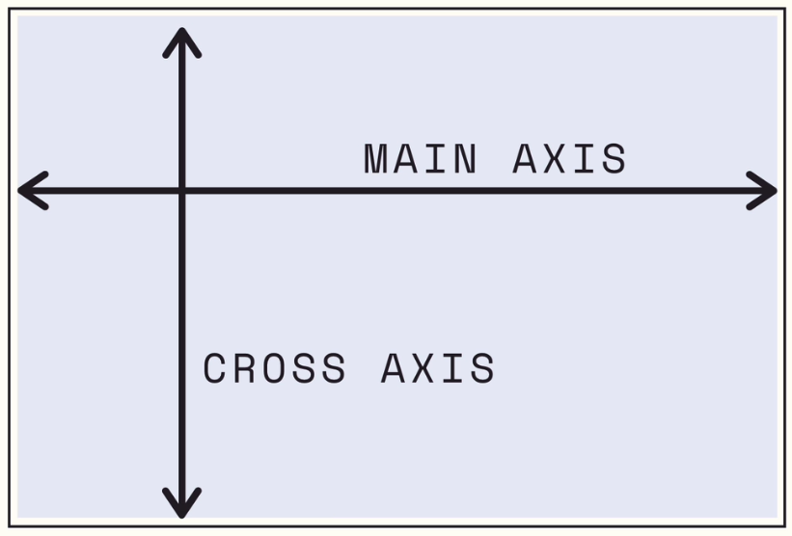 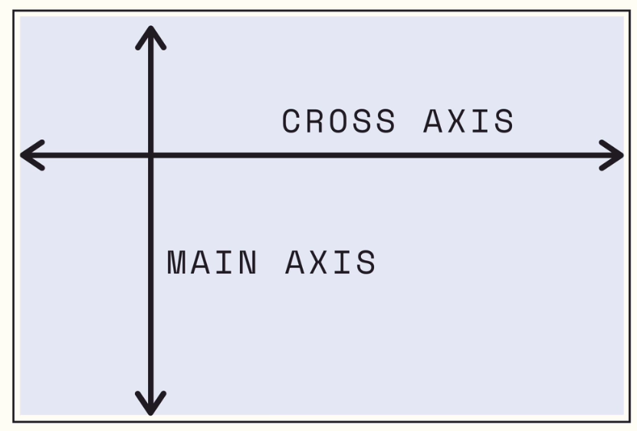

* **The main axis and the cross axis don’t always represent the same left-to-right or top-to-bottom directions, as can be seen from the picture above. Each one could represent each of these directions. They are simply markers for the directions in which our flex-items are going to flow.**
* **By default, the flex-items within a flex container will be aligned from left-to-right. Which means the main axis will be from left-to-right.**
* **But we can change the main axis to be top-to-bottom and make our content go into a column. Or we can reverse the axis and make it go from right-to-left.**

**Flex Properties**

* **These properties will only be applied to a container which has its display set to flex.**
* **flex-direction:**
  + **sets how flex items are placed in the flex container.**
  + **this property sets the main axis and its direction**
  + **the direction of the text is also taken into account. If the direction is set to rtl then the default main axis will be right-to-left.**
  + **row: main axis left-to-right (default)**
  + **row-reverse: main axis right-to-left**
  + **column: main axis top-to-bottom**
  + **column-reverse: main axis bottom-to-top**
* **flex-wrap:**
  + **sets whether flex items are forced onto one line or can wrap onto multiple lines**
  + **the default behavior is to prevent any wrapping of the content and instead shrink the content down such that all flex-items fit inside the flex-container (imagine we gave each flex-item a certain width and they should go out of the container because the container is smaller)**
* **no matter how much we increase the width of the items, they will not leave their container because the default flex-wrap is nowrap**

**setting flex-wrap: wrap will make the items which don’t fit inside the container, wrap onto the next row.**

* **The direction of the wrap is given by the cross axis;**
* **Regular wrap is left-to-right (direction column) or top-to-bottom (direction row)**
* **reverse-wrap is right-to-left (direction column) or bottom-to-top (direction-row)**
* **justify-content:**
  + **distributes the space between the items in a row or in a column**
  + **tells the flex container how to distribute the space and items along the main axis** 
    - **flex-start (default)**
    - **flex-end**
    - **center**
    - **space-between: makes our items go all the way to the left and to the right and then distribute space evenly between them**
    - **space-around: distributes space evenly between our items. The spaces between the first and last elements and their nearest container margin will be slightly smaller. That is because each element will have the same amount of space to its left and right.**
    - **space-evenly: spaces between elements and margins will be the same.**
  + **in case wrapping is activated, the justify content mode will apply to all rows/columns. The space between these rows/columns (so along the cross axis) will be modified by using align-items.**
* **align-items:**
  + **modifies the space between the group of rows/columns and the container**
  + **tells the flex container how to distribute the space and items along the cross axis**
  + **by default, it is set to stretch. For instance, if we have a direction of row and the items don’t have a height, their height will be stretched until they reach the end of the container. Same stands if the direction is column and the items don’t have a width set.**
  + **center**
  + **flex-start**
  + **flex-end**
* **align-content:**
  + **won’t do anything if we don’t have multiple rows/columns (wrapping activated)**
  + **align-content will control the space between our columns /our rows**
  + **center**
  + **flex-start**
  + **flex-end**
  + **space-between**
  + **space-around**
  + **space-evenly**

**Properties which apply to individual flex-items:**

* **align-self:**
  + **same concept as align-items (modifies spacing along the cross axis) but it applies to an individual flex item**
* **flex:**
  + **shorthand property**

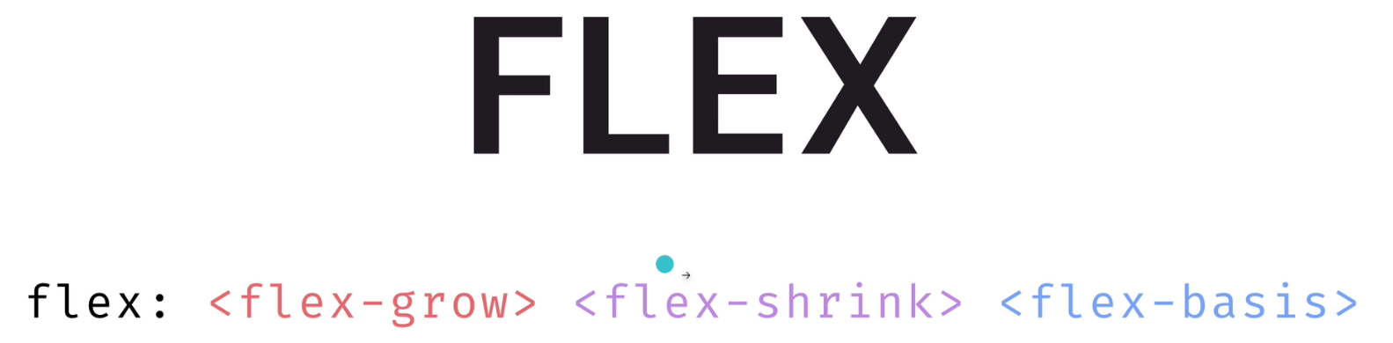

* + **sets how a flex item will grow or shrink to fit the space available in its container**
* **flex-grow:**
  + **expects a unitless value**
  + **dictates how much of the empty space this flex item should take**
  + **example:**

**If we have these 3 flex-items**

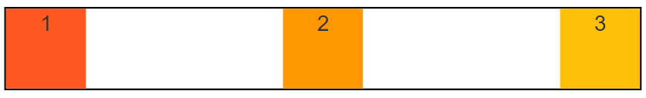

**And we would want the 2nd element to occupy all of the empty space in between, we could set its flex-grow to 1. Since it doesn’t compete for empty space with anyone, it will occupy all of it.**

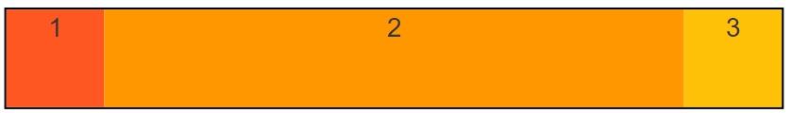

**Setting a 1 on all 3 elements would make them occupy the white space equally. If we were to give a value of 2 to the 2nd element and of 1 to the 1st and 3rd, the 2nd element would occupy twice as much space as the other two.**

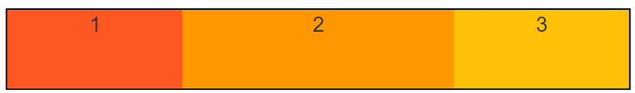

* **flex-shrink:**
  + **if there is not enough space in the container, sets how much items should shrink down to get to the right amount of space**
  + **an item with flex-shrink 3 will shrink 3 times faster than an element with flex-shrink 2**
  + **all elements have a default value of flex-shrink of 1. Thus, if the elements are too big for the container, they will get shrunk the same.**

**Default of 1:**

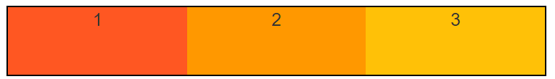

**2nd Element with a flex-shrink of 2;**

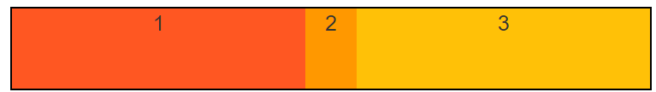

* **flex-basis:**
  + **sets the initial ideal size of a flex item, unless we set width and height ourselves**
  + **flex-basis:1000px;**
    - **If the direction is row => it will set the width of the element to 1000px**
    - **If the direction is column => it will set the height of the element to 1000px**
* **In consequence, the flex property is very useful. It allows us to set an initial value ( flex-basis) to an element, and then control how it should grow/shrink in relation to the empty space in the container.**
* **order:**
  + **allows us to change the order in which flex-items are displayed in a container**
  + **flex items are displayed based on their order, in an ascending manner. If they don’t have an order defined, they will be displayed in the order in which they are declared (called source order).**
  + **why? Could be used to improve the user experience for a user using a screen reader for example. If we have a title, a description and a date for an article, we would want the title to be read first. But the date should be rendered first.**

**Trick when working with flex box. It is easy to push an element to any direction by setting its margin for the opposite direction to auto.**

**Trick for centering an element with flex box. Setting both justify-content and align-items to center.**

**Media Queries**

* **they allow us to specify styles which only apply on certain screen sizes**

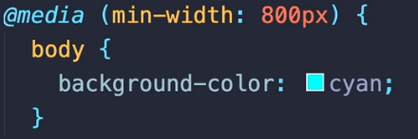

**­­ The media query starts with @media. Inside the parenthesis, we will place the condition based on the size of the viewport and inside the accolades, we will place our selectors.**

* **There are certain keywords used in conjunction with media queries.**

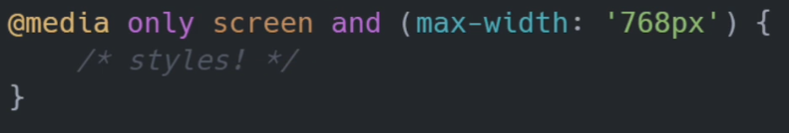

* **only:**
  + **Since certain older browsers don’t support media queries, all the styles we declare in media queries would get applied, regardless of our conditions. The only keyword ensures that the styles do not apply unless the browser is able to read media queries.**
* **screen:** 
  + **media type**
  + **There are multiple media type keywords which work with media queries, the 2 most common being screen and print.**
    - **screen: only apply the styles for a screen**
    - **print: only apply those styles when the page gets printed**
* **and:**
  + **logical and**
  + **links multiple conditions together**
* **or:**
  + **logical or**

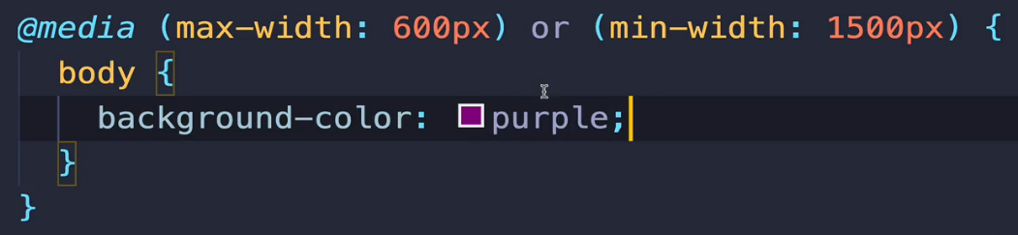

* **not: logical not**

**Media Features:**

* **the keywords we use within our media query ( min-width and max-width for our previous examples)**

[**https://developer.mozilla.org/en-US/docs/Web/CSS/CSS_media_queries/Using_media_queries**](https://developer.mozilla.org/en-US/docs/Web/CSS/CSS_media_queries/Using_media_queries)

**Approaches when building responsive websites**

* **Desktop First**
  + **Building your website to work on a desktop layout and then adjusting it for smaller screen sizes**
* **Mobile First**
  + **Building your website to work on a mobile layout and then adjusting it for bigger screen sizes**

**CSS Grid**

* **Just like with flex, in order to use the grid layout we have to define a container as display: grid. The items within it will be called grid items.**
* **A big difference between flex and grid is that with flex, we work with either rows or columns at one time. With grid, we work with rows AND columns.**
* **By default, a grid will work from left-to-right. If we had changed our language to work from right-to-left, the grid will behave the same.**
* **inline-grid:**
  + **setting display to inline-grid will also make the container a grid container while treating that container as an inline element.**
* **grid-template-columns**
  + **help us specify how many columns we want**
  + **work with percentages, pixels and fr.**
  + **units of measured passed can be combined:**
    - **grid-template-columns: 50% 2fr 1fr (first one takes 50%, 2nd and 3rd occupy the rest 50% with the 2nd one being 2 times larger;**
    - **grid-template-column: 100px 1fr 100px ( 1st and 3rd occupy 100px, the middle one occupies all the empty space)**
* **grid-template-rows** 
  + **sizing of our grid rows**
  + **in case we define something like 1fr 1fr 1fr (so 3 equally sized rows) but we have more elements, the first 3 will respect our definition and the next one will be squashed in, to fit the rest of the container**
* **fr:** 
  + **stands for fraction**
  + **it represents an even proportion of the grid, which is useful when we don’t want to calculate % widths**
  + **for example grid-template-columns : 50% 50% would work, it’s just easier to work with fr.** 
    - **50% 50% is equivalent to 1fr 1fr. Saying 1fr 1fr says “Make me 2 equally sized columns”**
    - **33.33% 33.33% 33.33% ⬄ 1fr 1fr 1fr.**
    - **grid-template-columns: 1fr 2fr 1fr will make 3 columns, with the middle one being 2 times as large as the ones on the left and right.**
* **grid-template:**
  + **shorthand property for defining both the rows and the columns**
  + **first we define the rows and then the columns separated by a /**

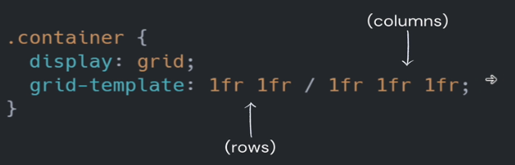

**Other column & row styles:**

* **minmax()** 
  + **allows us to define a minimum and a maximum value for the width a column should span/ for the height a row should span.**
  + **the parameters represent the minimum value and the maximum value, in that order**
  + **Each instance of minmax will represent data for one column**

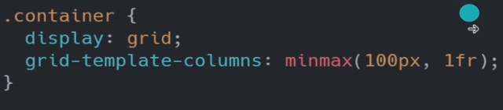

* + - **One column with a min width of 100 px and max width of 1fr;**



* + - **2 columns with their defined dimensions**
* **These function can be combined with “fixed” declarations:**



* + - **3 columns …**
* **Most commonly used pattern:**
  + **A fixed number for the minimum value and a more dynamic value ( fraction or percentage) for the max value**
  + **In order to make the content of our grid items to not overflow, we can set the minimum value fixed, and maximum value to the auto keyword.**
* **repeat:**
  + **parameters: number of repetitions, row/column definition**

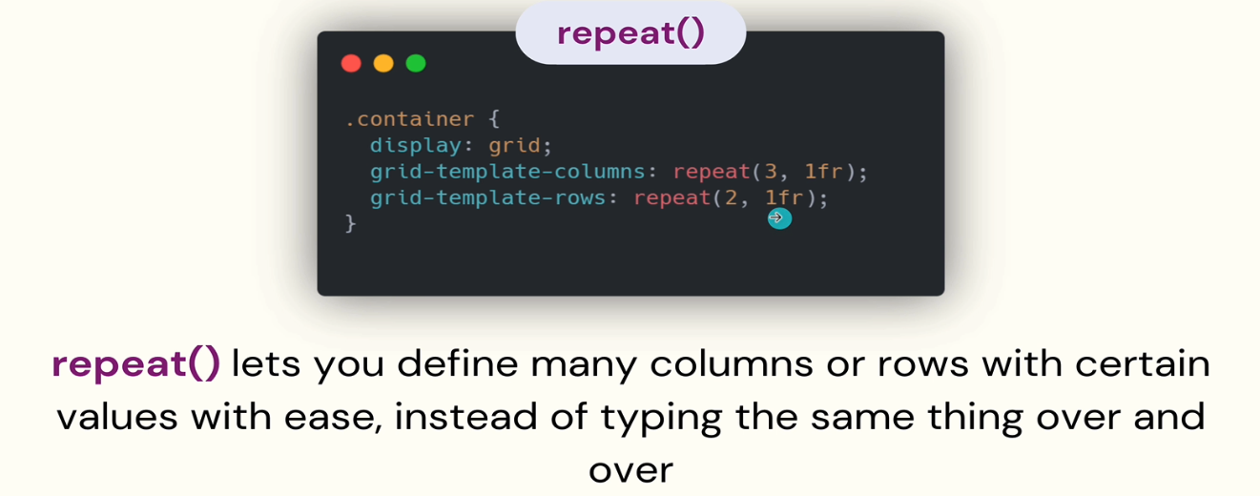

* + **Also works with grid-template**



* **fit-content:**

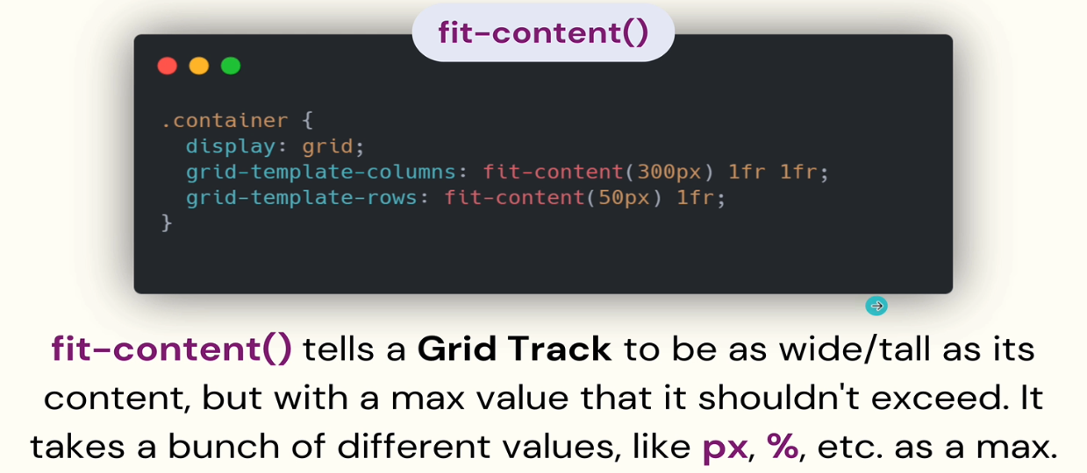

* **just like minmax(), it alters the width of columns and the height of rows**

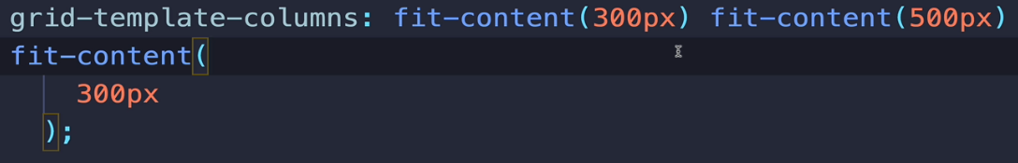

* + - **3 columns, each with the precise width that will fit their content and a maximum width set. If their content would exceed the upper limit, it will get clamped.**

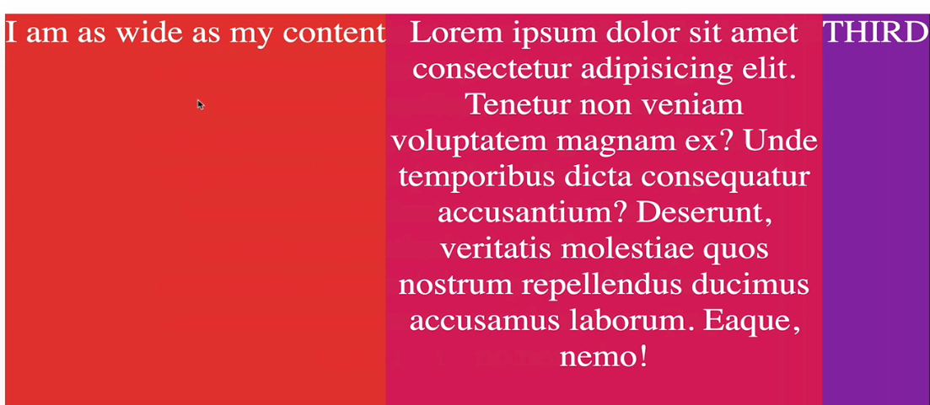

* + - **We can see the content of the 2nd column hit the 500px upper limit and got clamped.**
* **column-gap and row-gap:**
  + **easily control the spacing between our rows and columns**

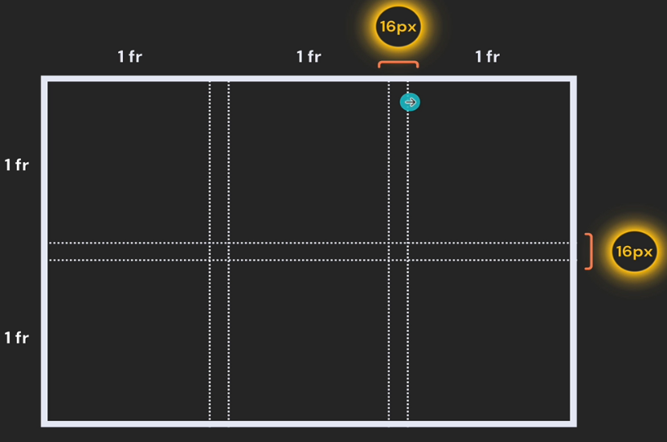

* **grid-gap / gap:**
  + **shorthand property used to set both row-gap and column-gap**
  + **1 value => sets the same value for both**
  + **2 values => 1st value is the row-gap, 2nd is for the column-gap**

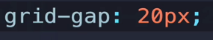

**Properties which apply to individual grid-items:**

* **By default, a grid item with no specified grid styles will occupy 1 cell (1 row and 1 column) in the grid.**

**Positioning grid items:**

* **Using number values, we can specify which grid lines our grid item should span.**
  + **grid-column-start**
  + **grid-column-end**
  + **grid-row-start**
  + **grid-row-end**
* **Enable Layout -> grid container for an easier visualization of the grid lines.**

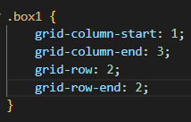

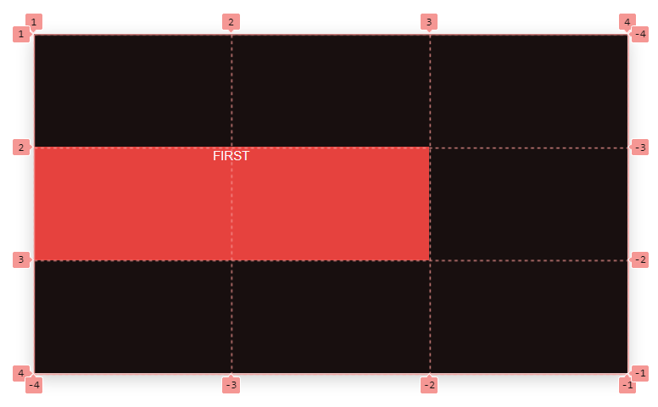

* **Instead of a line number, we can also use the span keyword.**
  + **The span keyword refers to grid tracks ( cells ), not to grid lines.**

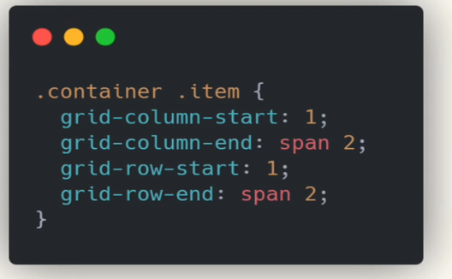

* + **Also, we don’t always have to specify its starting position if we are satisfied with the default. Having 2 elements means they will be placed at (1,1) and at (1,2).**
  + **Setting this then**

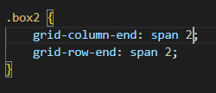 **will make our grid look like this**

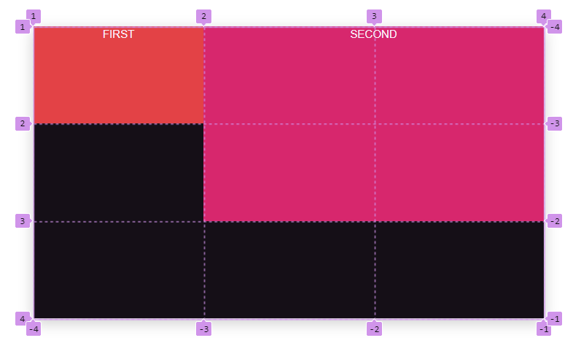

**Any other element would then occupy the next available position.**

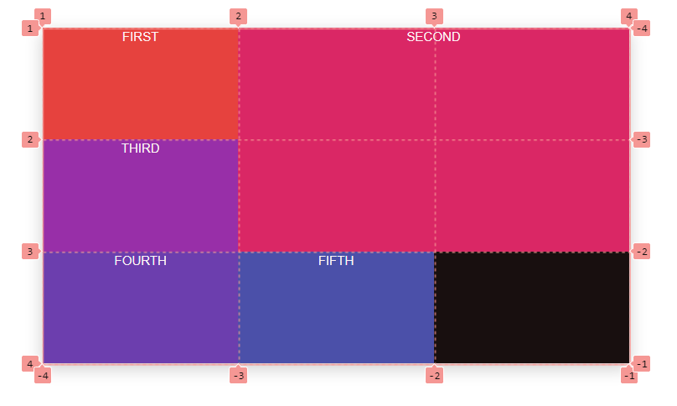

* **grid-column and grid-row:**
  + **shorthand properties so we do**
  + **n’t have to use start and end**
  + **<start-value> / <end-value>**
  + **a single value will specify the start line with the default span of 1.**
* **grid-area:**
  + **an even shorter version**
  + **<row-start> / <column-start> / <row-end> / <column-end>**

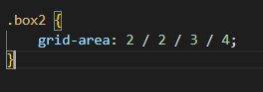 **⬄** 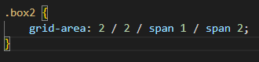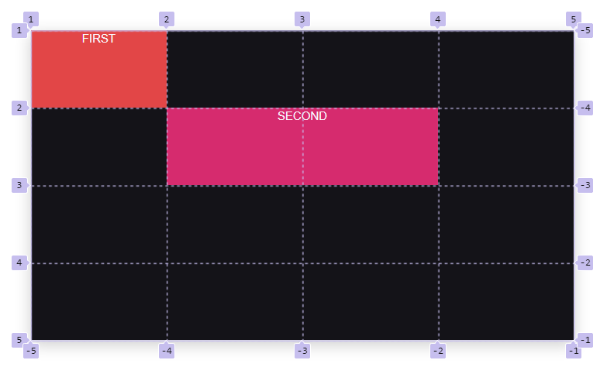

**Naming grid lines**

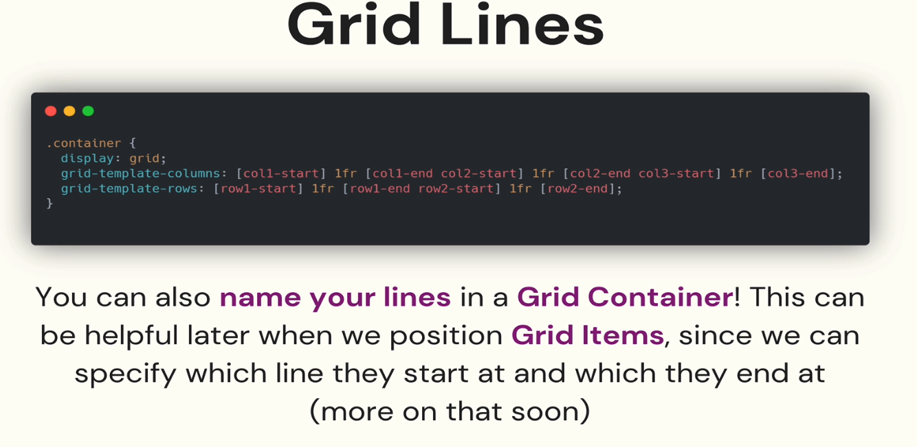

* **the syntax:**
  + **we have 3 columns and 2 rows ( we can tell that by looking at the fr)**
  + **before the first line, inside square brackets, we have the name of the first line**
  + **After the first line, inside square brackets, we have the name of the second line**
  + **And so on**
  + **We can see the 2nd line for instance is called both col1-end and col2-start**
* **Layout -> Show line Names (inside the dropdown): to see the line names**

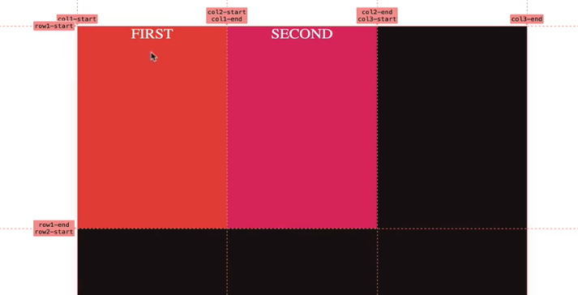

**We can then use these line names when we are positioning our grid items.**

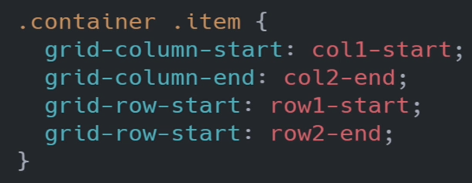

* **grid-template-areas:**
  + **a very powerful tool for building grids**
  + **we use grid-area property to assign names to our grid items**

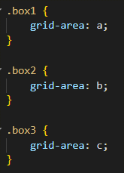

* + **Using the grid-template-areas property, we can “map” how our grid should look like using these elements**

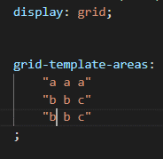

**Thus constructing this layout:**

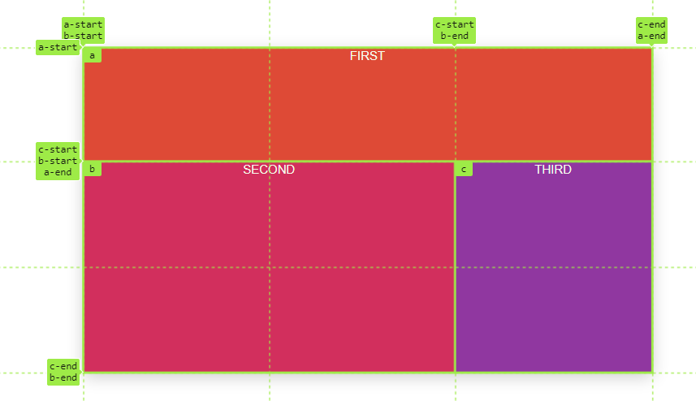

**Layout -> Show area names: To see the areas we defined**

**We can also see that the lines have automatically been named for us**

* **It isn’t mandatory that we define rows and columns when working with grid-template-areas, but it can be helpful to first declare the dimensions of our grid and then map elements onto the area**

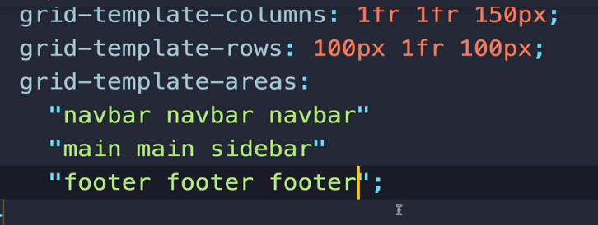

* **If we want empty spaces when working with areas, we can just place a dot at the positions which will be empty.**

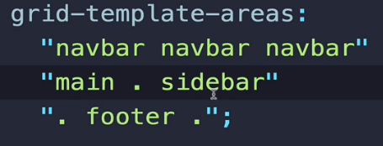

* + - 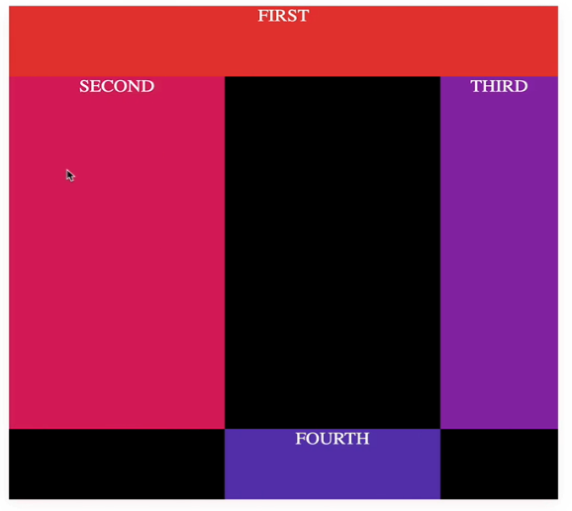

**Dynamic Grids**

* **If we don’t know how many items will be in the grid, how do we tell the container where to put them?**
* **grid-auto-flow** 
  + **tells the container how/where to add new items in the grid**
  + **it defaults to a row**

**Default behavior is to add new elements at the next position of the matrix (on the next empty row slot, as previously discussed)**

* **Setting it to column, would add the items in the order shown below**

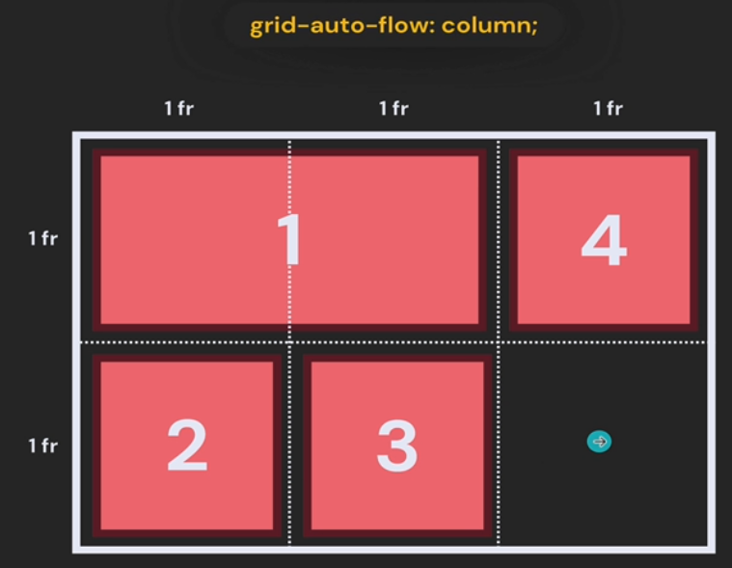

* **row dense / column dense:**
  + **In a situation where our elements don’t start at the first position and we have empty spaces in our grid, the empty spaces will be completed by using the dense keyword**
  + **example: Here we have the 1st element starting at the second position and the grid-auto-flow property set to column**

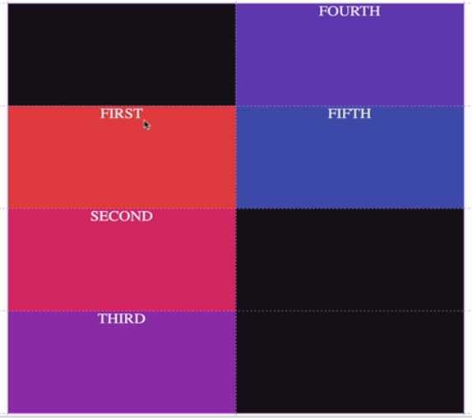

**Setting grid-auto-flow: column dense will yield the following result**

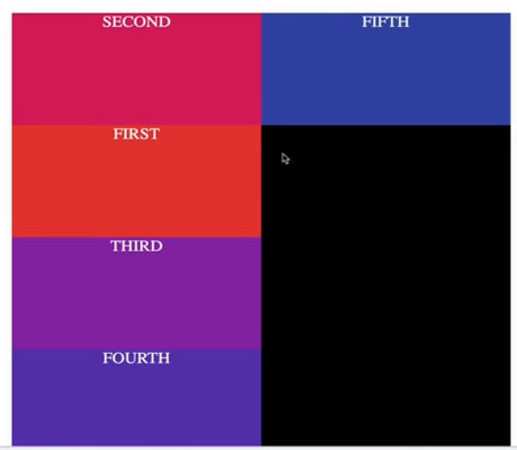

* **What if we add more elements than the size of the grid we declared?**
  + **We have our grid**



**But we have 16 elements. The first 8 will fill the position in our 2x4 grid, and the next ones will just be added**

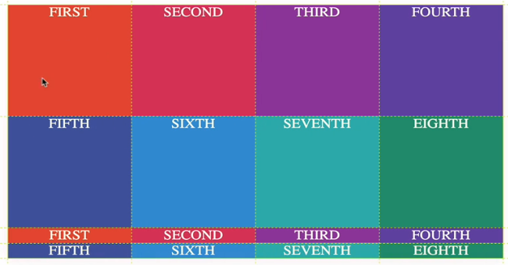

* **We use grid-auto-rows / grid-auto-columns**
  + **helps us define a height or a width for the automatically added elements**
  + **In our case, grid-auto-rows: 200px.**

**It seems our grid does indeed get bigger. Declaring a 3x2 grid and then adding 4 new elements results in this**

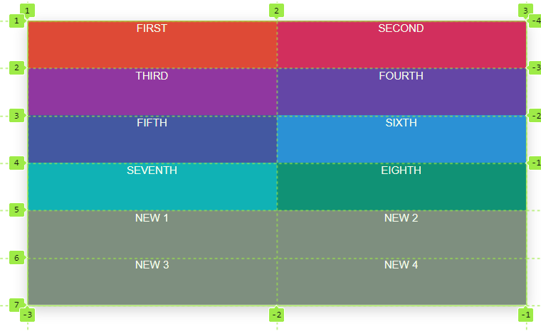

**Placing an element at position (6,1) works, even though this position wouldn’t exist in a 3x2 grid.**

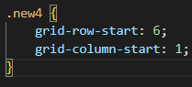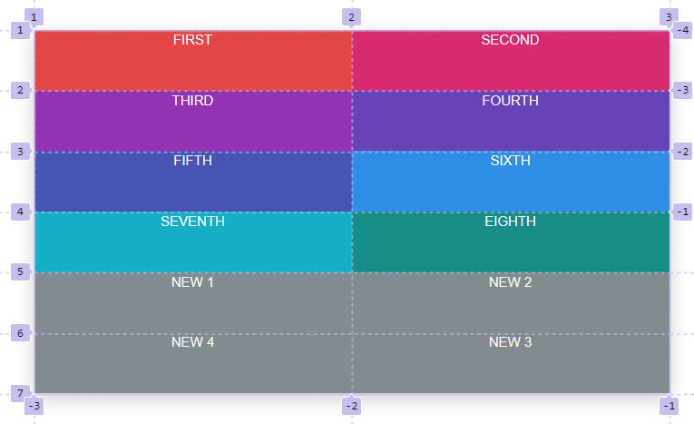

**Responsive Grids**

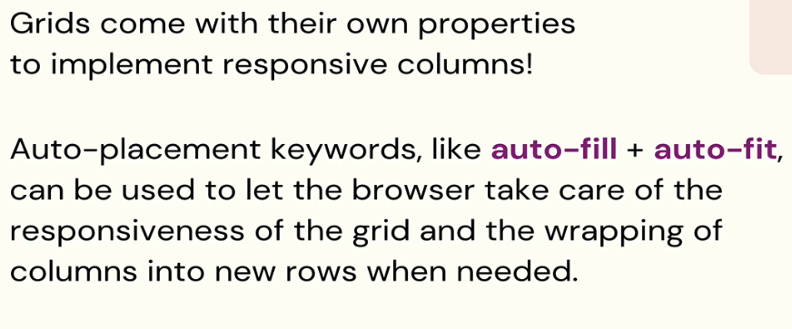

* **auto-fill and auto-fit**
  + **can be used as the first argument in the repeat method**
  + **This matters mostly when we have a container of a certain width/height**
  + **auto-fill will make the browser decide how many elements it can fit into our container**

** **

* + - **The browser will create 3 columns**

**Setting the width property to something else will also make the browser recalculate how many columns it can fit.**

**width: 1100 px;**

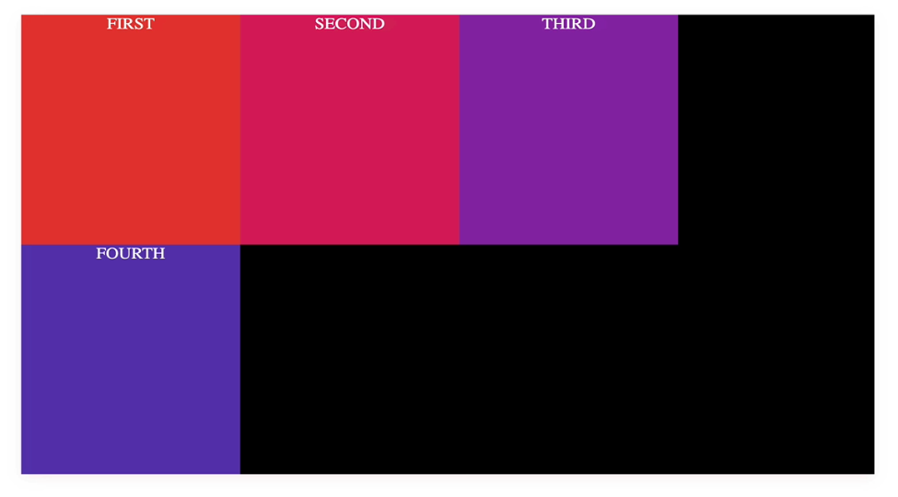

**This makes our grid responsive instantaneously**

* **auto-fit**
  + **auto-fit will behave just like auto-fill, except it will drop any empty space, IF that empty space is enough for a new element**
  + **example**

**Auto-fill**     grid-template-columns: repeat(auto-fill, minmax(200px, 1fr));

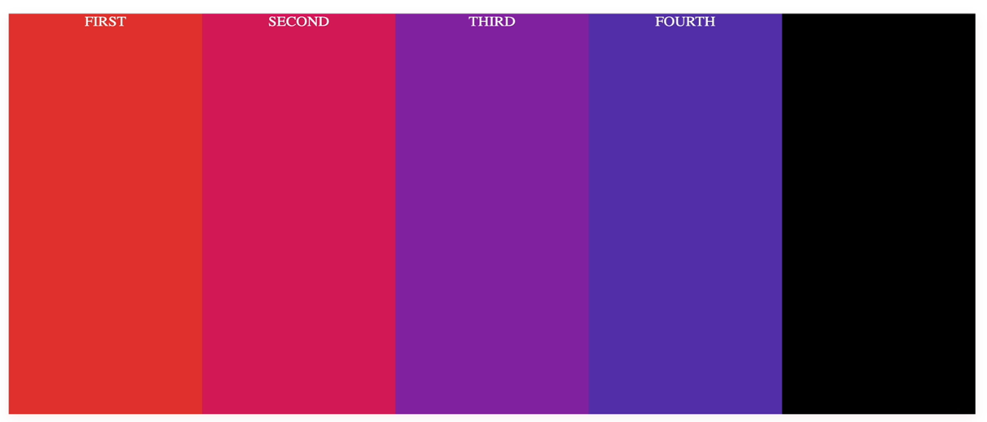

**The browser sees that it has enough space for a 5th element, but because the 5th element doesn’t exist, it just leaves the space empty.**

**Auto-fit**     grid-template-columns: repeat(auto-fit, minmax(200px, 1fr));

**Auto-fit will make the elements fit the whole space**

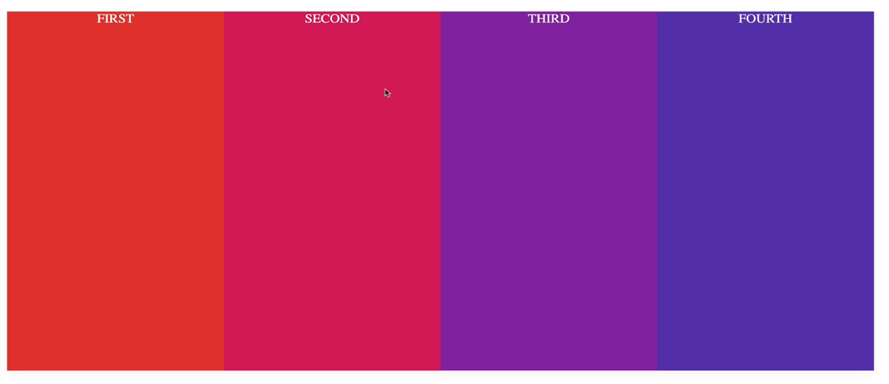

**But if our grid looks like this for example**

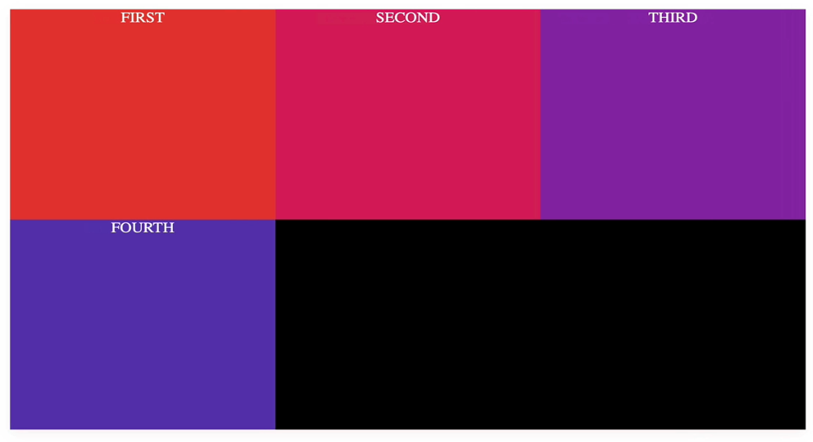

**Both will look the same. Auto-fit will neither drop the empty space, nor make 4th element bigger than the rest.**

**Keyframe Animations**

* **syntax:**
  + **@keyframes <name-of-animation> {**

**<step1>**

**<step2>**

**…**

**}**

* **First we declare the animation, then we apply it to an element**
* **When we declare an animation, there are multiple steps that we can make our animation have**

**2-step-animation:**

* **We use the from and to keywords. From is basically 0% and to is 100% of the animation’s lifetime**

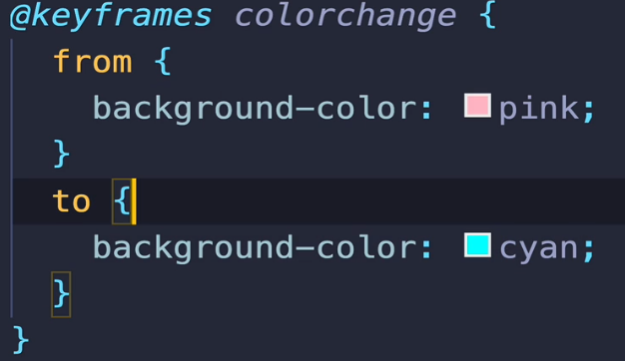

* **In this example, our element will go from pink to cyan. If it already has a background-color set, it will revert back to it as soon as the animation ends.**
* **Note these animations will start as soon as we refresh the page (unless we delay them ofc). They don’t need a trigger like transitions do.**

**Now to apply the animation, there are multiple properties we can set onto an element.**

* **animation-name** 
  + **name of the animation we want to apply onto our element**
* **animation-duration** 
  + **duration in seconds**
* **Using percentages, we can make our animation have multiple steps**

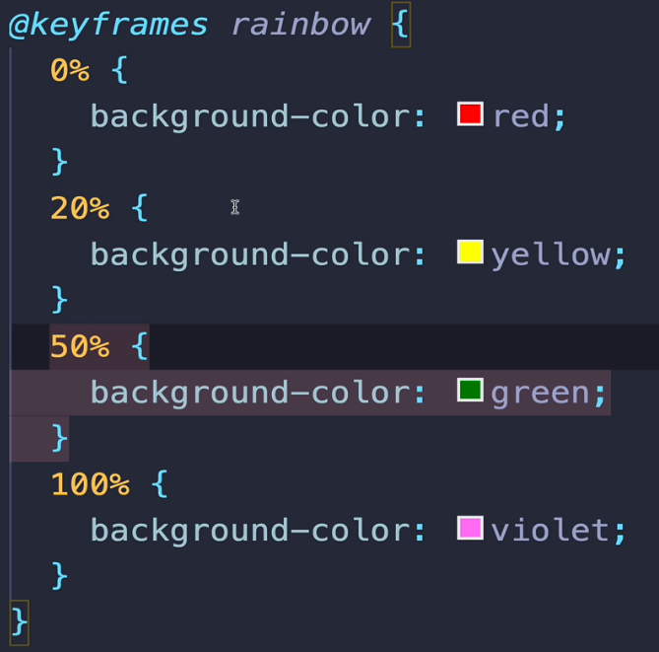

* **animation-iteration-count** 
  + **default 1**
  + **sets how many times the animation runs before stopping**
  + **receives a number or the keyword infinite**
* **animation-direction** 
  + **default normal**
  + **sets whether the animation should run in its default direction (0% to 100%) or not**
  + **reverse** 
    - **animation runs 100% to 0%**
  + **alternate** 
    - **animation will alternate between 0% to 100% and 100% to 0%**
  + **alternate-reverse** 
    - **animation will alternate between 100% to 0% and 0% to 100%**
* **animation-delay** 
  + **sets the delay of the animation’s start**
* **animation-timing-function** 
  + **default ease**
  + **linear: no speeding up**
  + **sets the timing function (same as for transitions)**
* **animation-play-state** 
  + **pause: pauses the animation**
  + **running: animation continues its run**
  + **typically set dynamically using JS**
* **animation-fill-mode** 
  + **controls how the animation should behave during its first and last state ( or before and after them)**
  + **forwards** 
    - **When an animation normally ends (hits 100%) it reverts back to its pre-animation state. Setting this property to forwards will make the animated element retain its end state.**
  + **backwards**
    - **When an animation has a delay, setting this property to backwards will make the element have its 0% state applied to it, even though the animation hasn’t started yet (so even during the delay time).**
  + **both** 
    - **Applied the effects of both forwards and backwards**
* **animation** 
  + **shorthand property for all those we’ve learned so far**

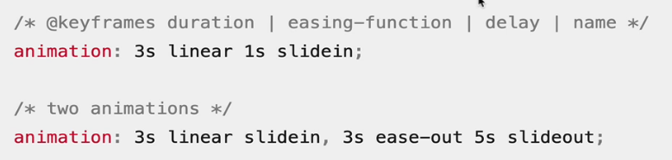

* **Whenever we have identical steps in our animations, we can write them one after the other, separated by a comma like this**

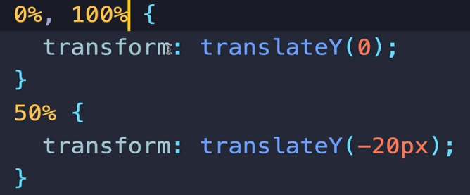

**Before and After Pseudo-elements**

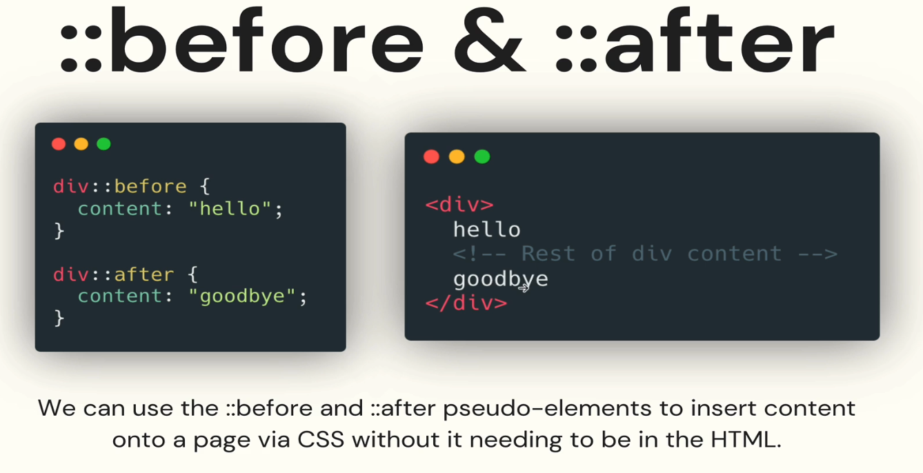

* **Inserts child elements of the selected element ( first or last children)**
* **It doesn’t go before/after the element | It goes before/after that element’s content ( the content property is the one which holds what will get inserted)**
* **We don’t necessarily need to insert content only. We can leave the content empty and insert any style we would like to have before our selected element**

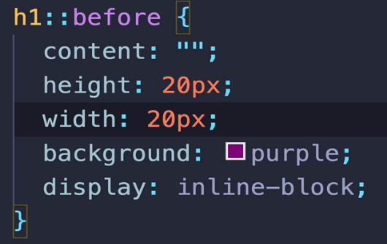

* **They are mainly used for decorative purposes**
  + **One example of using them is for creating quotes around text**
  + **content: open-quote / closed-quote**
* **Very useful website for Html Symbols:** [**https://www.toptal.com/designers/htmlarrows/symbols/**](https://www.toptal.com/designers/htmlarrows/symbols/)
  + **Example for quote: **
* **If someone is using a screen reader, they will encounter our markup which is only used for visual purposes ( like the quotes above) and that is dumb. Also it’s not useful for webcrawlers.**
  + **Before and after elements are great for decorative elements and they will not clutter what is indexed/read by seo crawlers or screen readers.**
* **In conclusion, we want to use before and after whenever we need decorative elements and we shouldn’t clutter our markup with html which doesn’t relay any important information**

**Modern CSS**

* **Variables:**
  + **Helps with DRY ( do not repeat yourself ) coding**

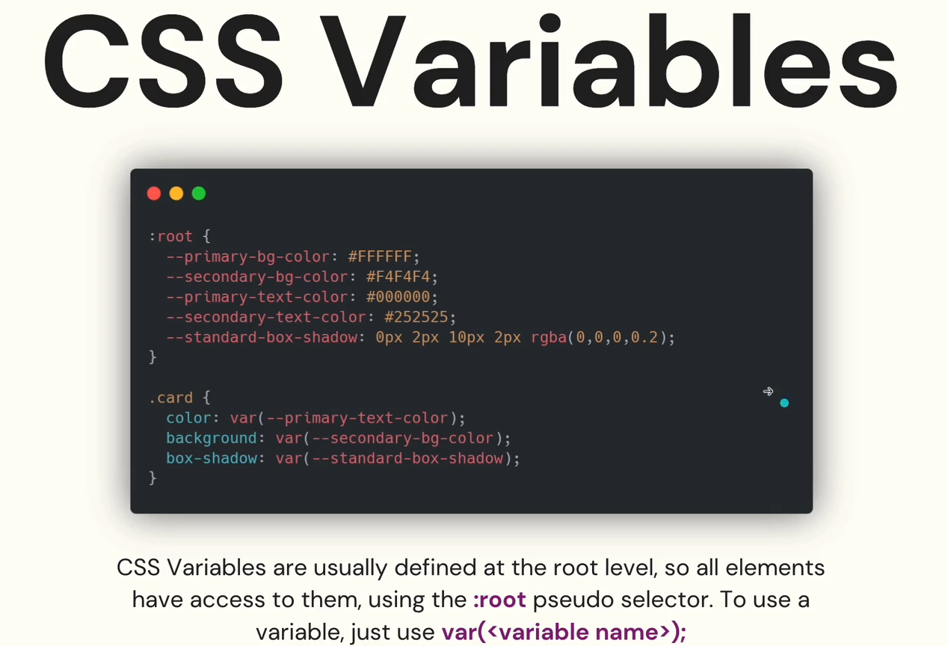

* **:root pseudoclass matches the root element of the tree representing the document (DOM)**
  + **In html, :root represents the <html> element and is identical to the .html selector except that :root has a higher specificity**
* **We can declare variables everywhere we want:**
  + 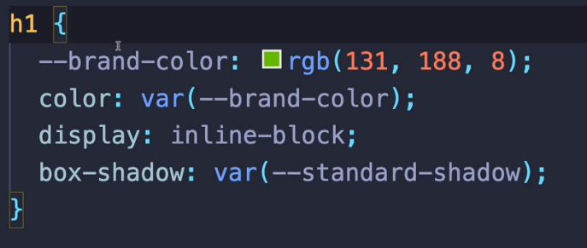
  + **Now, only the h1 elements ( elements selected by that selector) will have access to the --brand-color variable.**
  + **Basically, it’s like the scope from other programming languages. If I declare a variable within a certain scope ( selector ) then I will only have access to the variables within elements of the scope ( which are matched by the selector )**

**Variables and Media Queries**

* **If we want to override certain variables depending on the screen size, we can:**
* 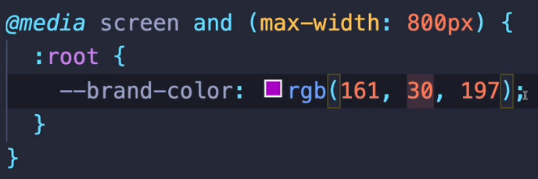

**Calc:**

* **Allows us to do some quick math within our css** 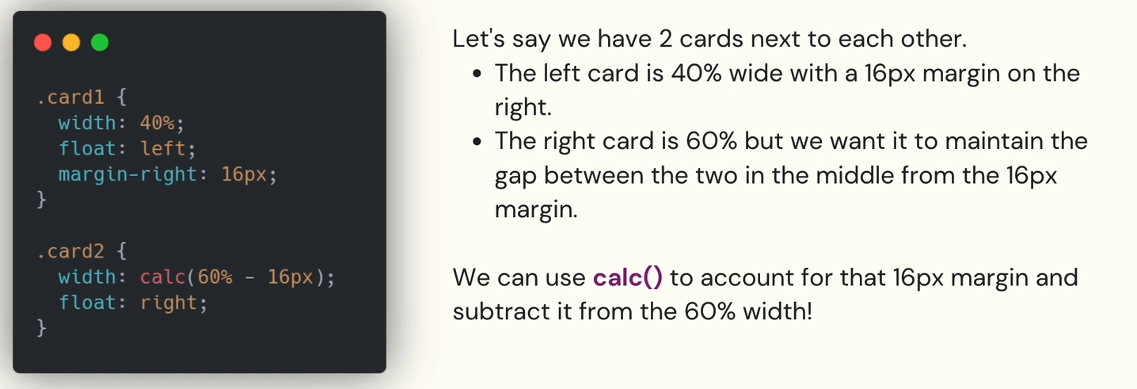
* **Tips and tricks when using calc:**
  + **We can use 4 operators** 
    - **addition ( + )**
    - **subtraction ( - )**
    - **multiplication ( * )**
    - **division ( / ) . Division by 0 causes errors !**
  + **Whitespaces between operators and items could cause errors**
    - **Multiplication and Division will work without them BUT Addition and Subtraction will throw an error**

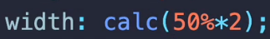 **WORKS**

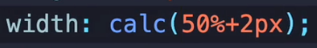 **ERROR**

* + **We can nest calc functions**



* + **We can use CSS variables inside calc functions as well**

